
Wolbachia Gel Electrophoresis Protocol
Adapted from:

Place a check mark next to each step after you complete it. Only use the dry erase markers.
__________ Put on laboratory gloves (it is important to use sterile technique).
__________ Carefully disinfect your lab table surface with 70% ethanol solution and paper towels. Spray your gloves with the 70% ethanol solution.
PREPARE THE RUNNING BUFFER

_______ | 1 | If not prepared in advance, prepare a 1X working solution of electrophoresis running buffer by adding TBE powder to deionized (DI) or distilled water. Follow manufacturer guidelines for specific measurements. | 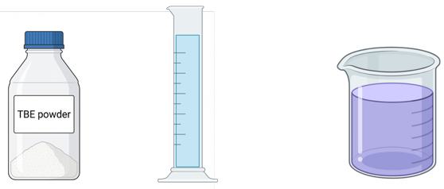  +  =  DI H₂O  TBE powder
1X running buffer
PREPARE THE GEL
_______ | 2 | Place a clear gel tray into the white casting platform. | 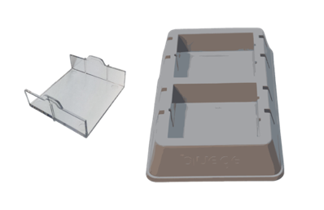
_______ | 3 | Select the 9-tooth comb, orient downward, and insert into the top ridges above the gel tray in the casting platform. | 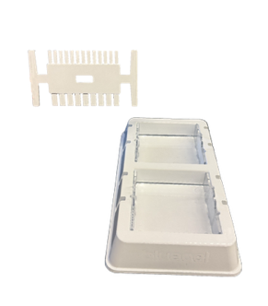
_______ | 4 | FOR ONE 2% GEL: In a 125 ml flask (or larger), soak one SeeGreen All-in-One Agarose Tab in 20 ml distilled water.  FOR TWO 1% GELS: In a 125 ml flask (or larger), soak one SeeGreen All-in-One Agarose Tab in 40 ml distilled water. | 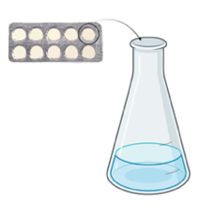  1 gel = 20 ml  2 gels = 40 ml
_______ | 5 | Swirl ~3 minutes until the Tab is completely dissolved. | 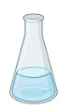
_______ | 6 | Place in the microwave for 60 seconds or until the solution starts to boil. Do not allow the solution to boil over. |   60 sec    Don’t allow the solution to boil over!
 | 7 | Using a hot hand protector, remove the flask from the microwave and gently swirl, but do not shake, to mix the agarose without creating bubbles in the solution. If agarose crystals are still present, microwave an additional 5-10 seconds. Allow the solution to cool briefly (to 60-70º C). | 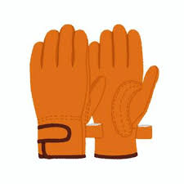
_______ | 8 | Carefully pour the solution into the gel tray and let it sit for at least 10 minutes. Do not move the tray. Disrupting the gel before it is fully set may affect your results. | 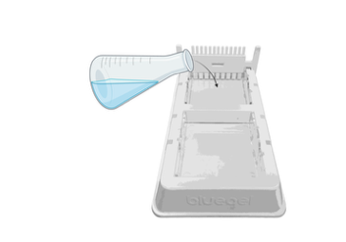
LOAD THE GEL
_______ | 9 | Once the gel is cooled and firm to the touch, slowly remove the comb. Lift the gel tray from the casting platform and wipe off excess agarose from the bottom of the gel tray. Do not remove the gel from the tray. | 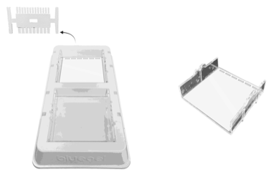
_______ | 10 | Place the solidified gel (along with gel tray) into the buffer chamber. | 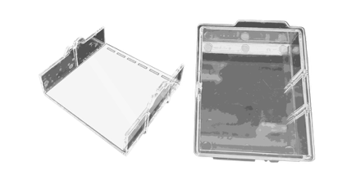
_______ | 11 | Place the buffer chamber into the blueGel base. The wells should align with the top (-) end of the tank (opposite the power button). | 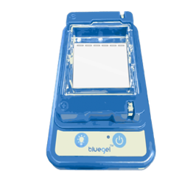
_______ | 12 | Pour 30 ml of the prepared 1X TBE running buffer into buffer chamber. The buffer should barely cover the gel and wells. If air bubbles are present in the wells, gently shake the unit to remove bubbles. | 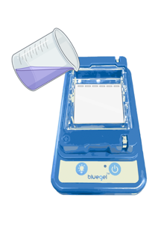
_______ | 13 | Starting with the DNA ladder, gently hover your pipette tip over the first well and load 5 μl. Changing tips between each sample, load the rest of your PCR products (10 μl each) in order. When finished loading, turn off the light. | 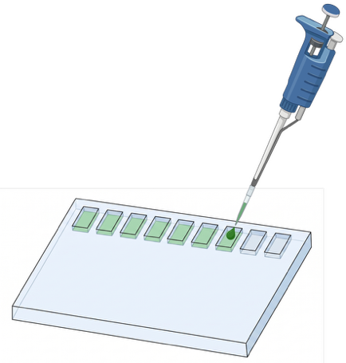  Change tips between each sample!
   | Lane | Volume | Content | DNA
  ____ | 1 | 5 μl | DNA Ladder
  ____ | 2 | 10 μl | PCR #1 | Sample 1
  ____ | 3 | 10 μl | PCR #2 | Sample 2
  ____ | 4 | 10 μl | PCR #3 | (+) Arthropod Control
  ____ | 5 | 10 μl | PCR #4 | (-) Arthropod Control
  ____ | 6 | 10 μl | PCR #5 | (+) DNA
  ____ | 7 | 10 μl | PCR #6 | (-) Water
_______ | 14 | Replace the caps on your PCR products and give to your instructor for storage at 4º C. | 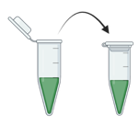
RUN & VISUALIZE THE GEL

_______ | 15 | Treat the inside of the orange cover with the ClearView solution to prevent fogging. | 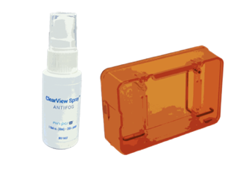
_______ | 16 | Place the orange cover on the blueGel electrophoresis system such that the (+) and (-) electrode symbols align with those on the blue base. | 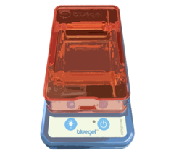
_______ | 17 | Press the power button and make sure that the green light is illuminated. Allow the gel to run for about 20 minutes. Use the lightbulb button to occasionally view the bands as they migrate down the gel. Note: The DNA stain is photosensitive and weakens with exposure to light. | 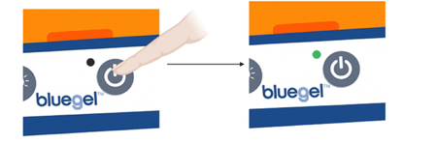  20 min
_______ | 18 | Use your cell phone, or other camera-ready mobile device, to take a picture (or video) of the gel. For best results, use the Fold-a-View photo documentation hood. If the image is hazy, wipe off condensation from the inside of the orange cover and reapply the ClearView solution. | 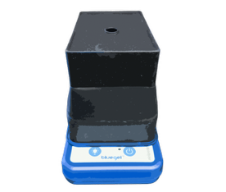
_______ | 19 | Once the run is complete, press the power button to turn off the system. | 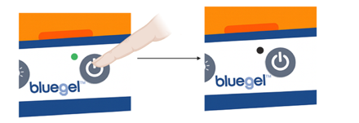
Illustrations created with BioRender.

