
Wolbachia Gel Electrophoresis Protocol
Adapted from:

Place a check mark next to each step after you complete it. Only use the dry erase markers.
__________ Put on laboratory gloves (it is important to use sterile technique).
__________ Carefully disinfect your lab table surface with 70% ethanol solution and paper towels. Spray your gloves with the 70% ethanol solution.
PREPARE THE RUNNING BUFFER

_______ | 1 | If not prepared in advance, prepare a 1X solution of electrophoresis running buffer by adding 1-part TBE concentrate to 19-parts deionized (DI) or distilled water. | 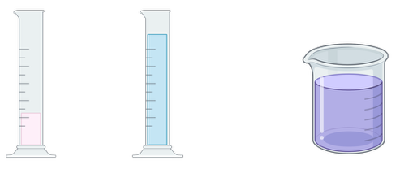  DI H₂O  TBE concentrate  1X running buffer  +  =

PREPARE THE GEL
_______ | 2 | Place the white MiniOne casting stand on a level surface and insert two gel trays. | 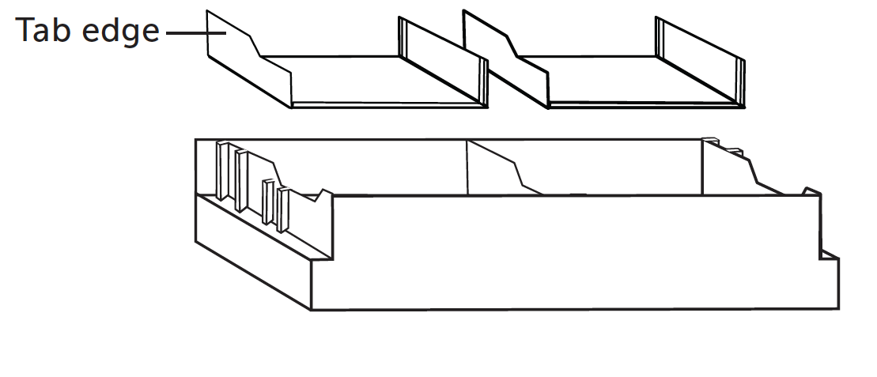
_______ | 3 | Select the 9-tooth comb, orient downward, and insert into the top ridges of the casting stand. | 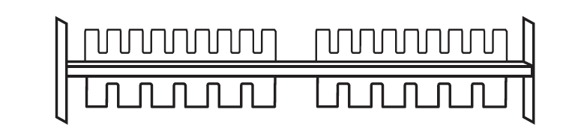
_______ | 4 | Partially peel the film of a GreenGel cup to vent and place in the microwave for 20 seconds. Make sure it is completely melted - look for chunks or shadows.  ** If preparing two gels, microwave both cups at once. Do not microwave more than five cups at a time. | 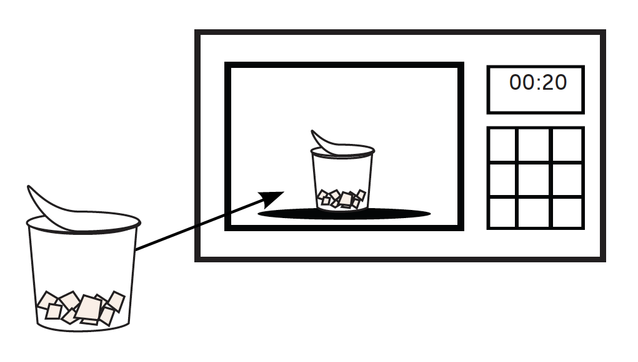
_______ | 5 | Allow the cup to cool for 15 seconds. Without shaking, gently swirl the cup to mix agarose without creating bubbles in the solution. If not completely dissolved, microwave for a few more seconds. | 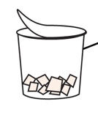
_______ | 6 | Carefully pour the hot gel into one of the gel trays and let it sit for at least 10 minutes. Do not move the tray. Disrupting the gel before it is fully set may impact your results. | 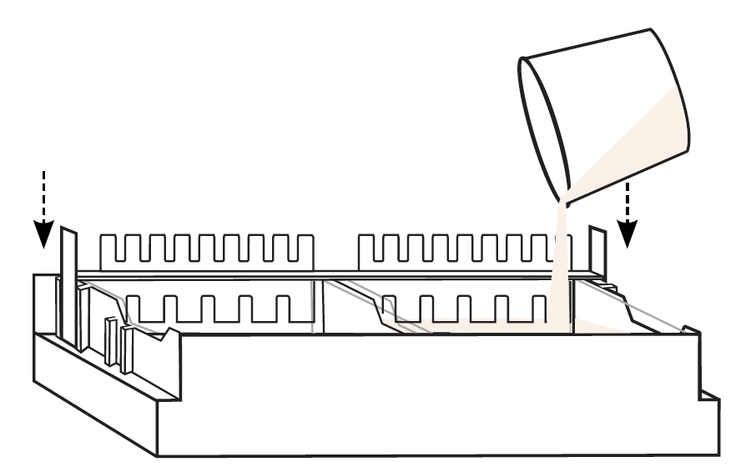

Instructions continued on next page

_______ | 7 | Collect a MiniOne black carriage, MiniOne gel tank, MiniOne black gel tray insert, and the MiniOne power supply. | 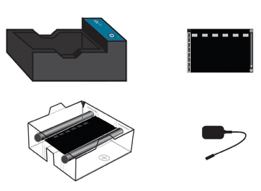  Black gel tray insert  Gel Tank  Carriage
_______ | 8 | Place the black gel tray insert into the bottom of the gel tank. The illustrated wells should be aligned with the top (-) end of the tank. | 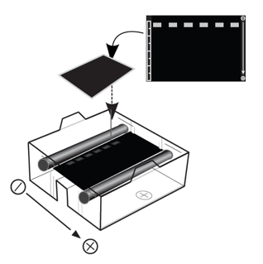  Power supply
_______ | 9 | Place the gel tank into the carriage.  - The gel tank should be level.  - The - /+ ends should be properly aligned.  - The electrodes should be touching the rivets. | 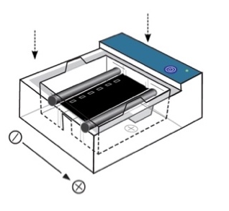
_______ | 10 | Attach the power supply and plug into the wall. | 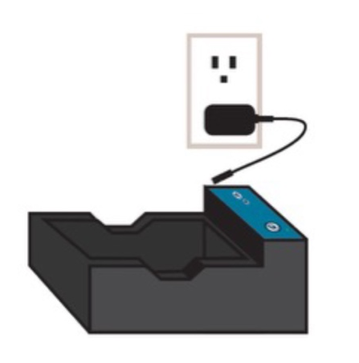
ASSEMBLE THE ELECTROPHORESIS SYSTEM
LOAD THE GEL
Instructions continued on next page

_______ | 11 | Once the gel is cooled and firm to the touch, slowly remove the comb. Lift the gel tray from the casting tray and wipe off excess agarose from the bottom of the gel tray. Do not remove the gel from the tray. | 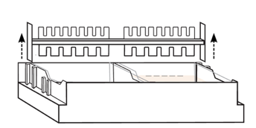  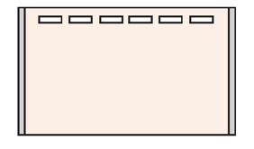
_______ | 12 | Place the solidified gel (along with gel tray) into the gel tank. The wells should align with the top (-) end of the tank. | 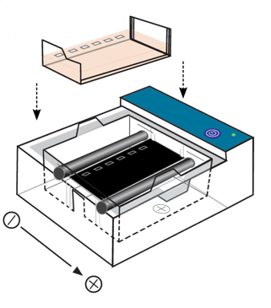
_______ | 13 | Pour 135 ml of the diluted TBE running buffer into one side of the gel tank (NOT the carriage) and allow it to flow to the other side. Ensure that air bubbles are not trapped under the tray. | 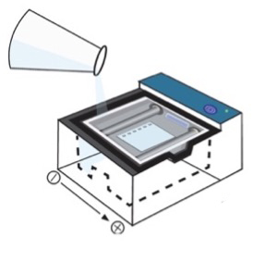  135 ml TBE
_______ | 14 | Press the smaller light button to turn on the low intensity blue light. This will help to visualize wells while loading samples. | 
_______ | 15 | Load 5 μl of the DNA ladder and 10 μl of each PCR product into the gel.  - Starting with the DNA ladder, gently hover your pipette tip over the first well and load 5 μl. Changing tips between each sample, load the rest of your PCR products in order (see table). When finished loading, turn off the light. | 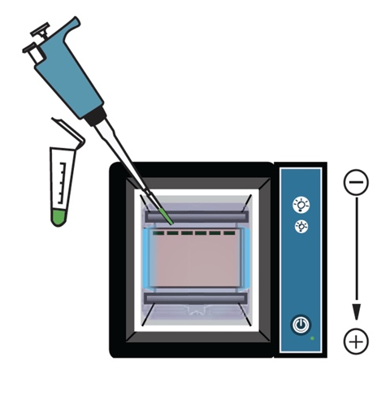  Change tips between each sample!
   | Lane | Volume | Content | DNA
  ____ | 1 | 5 μl | DNA Ladder
  ____ | 2 | 10 μl | PCR #1 | Sample 1
  ____ | 3 | 10 μl | PCR #2 | Sample 2
  ____ | 4 | 10 μl | PCR #3 | (+) Arthropod Control
  ____ | 5 | 10 μl | PCR #4 | (-) Arthropod Control
  ____ | 6 | 10 μl | PCR #5 | (+) DNA
  ____ | 7 | 10 μl | PCR #6 | (-) Water
_______ | 16 | Replace the caps on your PCR products and give to your instructor for storage at 4º C. | 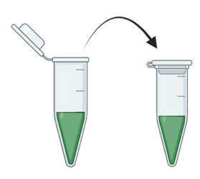

Instructions continued on next page

_______ | 17 | Place the orange photo hood on the carriage. | 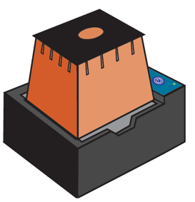
_______ | 18 | Press the power button to turn on the electrophoresis system. A green light should appear. If the green power LED does not appear, consult the MiniOne User Manual. | 
_______ | 19 | Allow the gel to run for about 20 minutes. Use the low intensity blue light to occasionally view the bands as they migrate down the gel. Note: The DNA stain is photosensitive and weakens with exposure to light. | 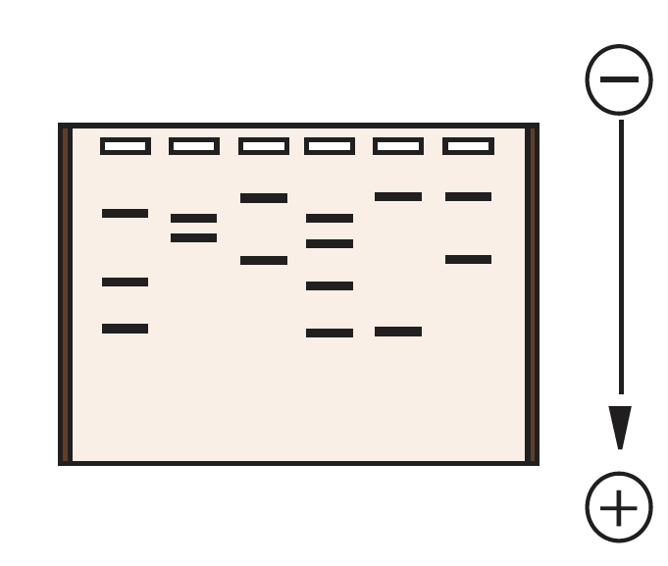
_______ | 20 | To obtain an image of the gel, press the larger light button to turn on the high intensity blue light. Place your cell phone (or other mobile device) directly over the viewing hole to take a picture and/or video. | 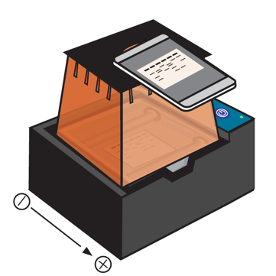
_______ | 21 | Once the run is complete, press the power button to turn off the system.
RUN & VISUALIZE THE GEL

