Bioinformatics: Analyze Sanger DNA Sequences
This protocol utilizes DNA Subway 2.0 (https://dnasubway.org/), an educational platform developed by the DNA Learning Center at Cold Spring Harbor Laboratory.

MATERIALS NEEDED

- Computer with internet access
- Shared folder containing sequencing results:
  - Sequencing Overview Document
  - .ab1 (trace) files
  - Arthropod phylogeny file; Wolbachia phylogeny file
GETTING STARTED

In this activity, you will analyze arthropod and Wolbachia DNA sequences using DNA Subway. The pink highlighted areas indicate fields that should be completed in Tables 1 & 2.

Sanger DNA sequencing files are labeled with sample ID followed by the primer name.
CO1F designates an arthropod sequence.
WSpecF designates a Wolbachia sequence.
CO1_SLF is specific to Spotted Lanternfly (arthropod).

Wolbachia sequence
Arthropod sequence
PS1_WSpecF
PS1_CO1F

Spotted lanternfly arthropod sequence
PS1_CO1_SLF_43F

PREPARATION: Identify and Record Sanger DNA Sequences for Analysis

_______ | 1 | Navigate to the shared folder.
_______ | 2 | Open the Sequencing Overview document.  - Record the sample IDs (file names) of the DNA sequences.  Arthropod (Table 1) = _______________ Wolbachia (Table 2) = __________________  - Record the QS value for each sequence.  Arthropod (Table 1) = _______________ Wolbachia (Table 2) = __________________  - Work with your class to complete the putative identification for each arthropod (Table 1 only).  Putative identification (based on morphology) = _______________________________
_______ | 3 | Return to the shared folder and download the .ab1 (trace) files to your desktop.
_______ | 4 | Download Arthropod and Wolbachia phylogeny files (FASTA format) with QS ≥ 30 to your desktop.

ARTHROPOD DNA Sequences
SELECT: Upload and Review DNA Sequences

_______ | 5 | Navigate to DNA Subway 2.0 and login (either as Guest or Create Account).  https://dnasubway.org/
_______ | 6 | Under the Projects tab, select Create Project >> Blue Line. | 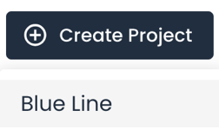
_______ | 7 | Enter a Project Title for the Arthropod data, select Sequencing Type >> Sanger, and click Create Project >. | 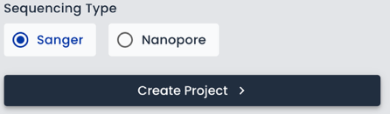
_______ | 8 | Under the Import Sequences menu, select Upload From Device.  Navigate to the downloaded files on your Desktop and select the arthropod (CO1F) .ab1 files to be analyzed. Using Table 1 for reference, only upload sequences with QS ≥ 30. Hold Ctrl (Windows) or Command (Mac) keys while selecting files to upload multiple sequences. Click Open. | 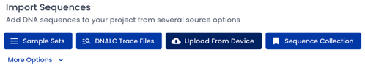
_______ | 9 | Uploaded sequences should now be visible under Project Files.  Orange caution symbols indicate files with low QS values; they should be deleted from Project Files to avoid downstream issues. | 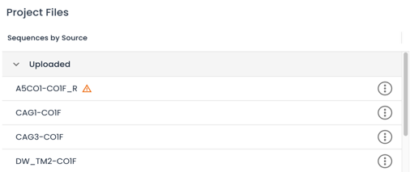  Low-quality sequence
_______ | 10 | Once the files are loaded, click on the first file to view the sequence. This will display the text view of the DNA sequence. Note the N’s at either end of the sequence. These represent low-quality base calls where the sequencer was unable to “call” the base. N=unknown; common at ends of Sanger sequences. | 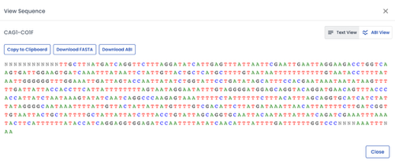  Terminal N’s
_______ | 11 | Select the ABI View button in the upper-right to view the chromatogram (trace file). Use the slider to scroll through the chromatogram. The QS for each base call is highlighted by purple bars above the chromatogram. Bars below the thin blue line are indicative of low-quality base calls (QS < 20).  After viewing the file, click Close. | 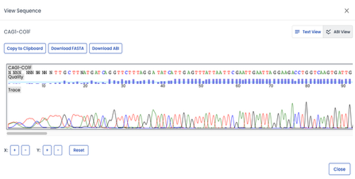  ABI View  Quality Scores
_______ | 12 | Repeat steps 10 & 11 for remaining files. When all sequences have been inspected, select Next Stop. | 
Screenshots taken from https://dnasubway.org
The next step will trim low-quality ends from the Sanger DNA sequences.

EDIT: Trim DNA Sequences

ARTHROPOD DNA Sequences
_______ | 13 | Edit >> Trim Sequences will trim the undefined N’s and associated low-quality base calls from the ends of each sequence. DNA Subway 2.0 provides two options:  - Auto Trim  - Manual Trim  Option 1: Auto Trim  - Select Auto Trim All to automatically trim all sequences with a single click of the button.  - Optional: You may use the drop-down menu under Manual Trim to view the modified sequences, or you may return to Select >> Project Files to view the trimmed chromatogram. Lower-case letters indicate low-quality base calls.  - If you are satisfied with trimming, select Save Trim and proceed to Step 14. Otherwise, select Revert to Original and proceed with Manual Trim.  Option 2: Manual Trim  - Click on an internal base. This will strike out (trim) all bases leading to that base. The trimmed region will appear in the embedded ABI Viewer for review. Select Save Trim and repeat for all remaining sequences. |   
_______ | 14 | When the gray All Trims Complete box appears in the upper right-hand corner of the Edit section, click Next Stop to proceed with Analysis.  Note: Most Wolbachia Project sequences are forward (CO1F) direction only. If your class sequenced forward (CO1F) and reverse (CO1R) directions, complete the Pair Sequences and Edit Consensus drop-down tasks to generate consensus sequences. | 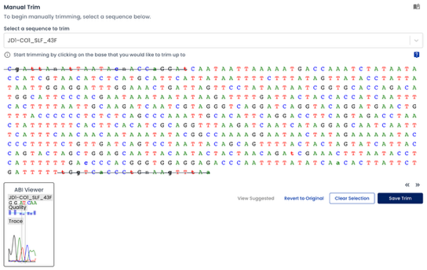  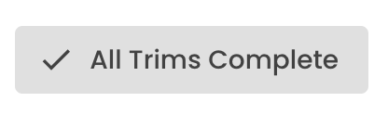  Trimmed bases
Screenshots taken from https://dnasubway.org
The next step will use NCBI BLAST to determine taxonomic identification.
ANALYZE - BLASTn: Determine Taxonomic Identity

ARTHROPOD DNA Sequences
_______ | 15 | Analyze >> BLASTn: Use the drop-down menu to select sequences for BLAST analysis. Click to highlight each sequence and select BLAST.  The program may take ~ 1 minute to compare the selected sequence(s) with a local database of sequences. When complete, the spinning circles will turn into LinkOut icons. | 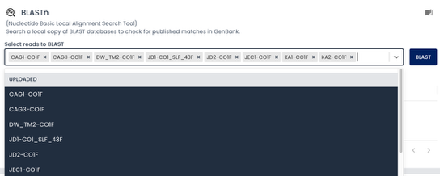  BLAST
_______ | 16 | Select the LinkOut icon to view BLAST results. Click on the name of each entry to review images and Wikipedia/EOL links. Do they match the putative identifications of each arthropod from Table 1? | 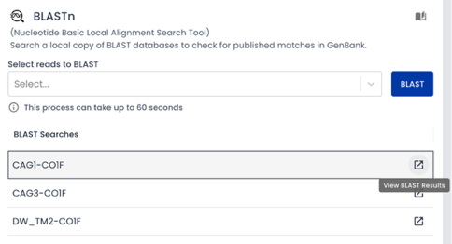
_______ | 17 | Optional: Results are based on DNA Subway’s local copy of reference sequences. If you prefer more resolution:  - Go back to the top of the page. Select >> Project Files and click to open the sequence.  - Select Download FASTA. Save to the desktop.  - Open a new browser window and navigate to NCBI BLAST. https://blast.ncbi.nlm.nih.gov/Blast.cgi  - Select the Nucleotide BLAST box.  - Upload the FASTA file as the Query Sequence. Scroll to the bottom and select the blue BLAST button.  The list of results will include Query coverage, % identity, and links to the nucleotide record. | 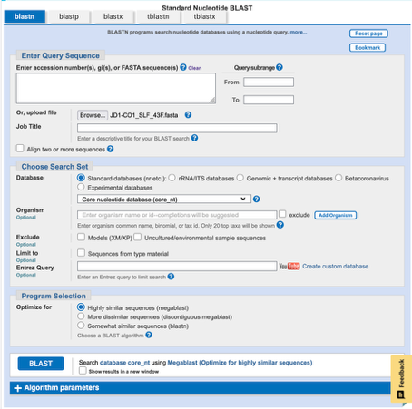  Copy/paste sequence or upload FASTA file  BLAST  #1  #2
_______ | 18 | Record the scientific name of your selected arthropod (based on the best BLAST hit) in Table 1.  Scientific name = __________________________________
_______ | 19 | Open a new browser window. Use Wikispecies (or similar resource) to learn more about the arthropod. Record the arthropod’s common name and taxonomic order (Table 1). In the example to the right, the taxonomic order would be Lepidoptera.  Common name, if any, of the arthropod = ______________  Taxonomic order of the arthropod = ___________________ | 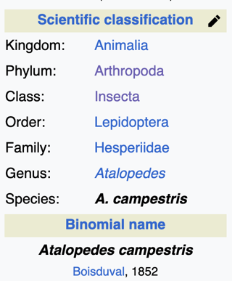
Screenshots taken from https://dnasubway.org, https://blast.ncbi.nlm.nih.gov, and https://species.wikimedia.org
The next step will build a phylogenetic tree to evaluate evolutionary relatedness with common arthropods.

ANALYZE - MUSCLE & PHYLIP: Build a Phylogenetic Tree

ARTHROPOD DNA Sequences
_______ | 20 | Scroll to the top of the page and click Select >> Import Sequences >> Upload From Device. Upload the Arthropod Phylogeny FASTA file (from Step #4). The arthropod reference sequences will automatically be added to Project Files. | 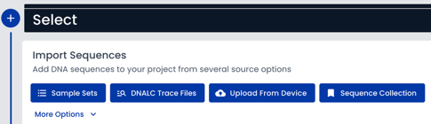
_______ | 21 | Scroll back to the bottom of the page and click on the Analyze header. Scroll down to the MUSCLE section. | 
_______ | 22 | Align sequences with MUSCLE:  - Use the drop-down menu to select all sequences from your project files, including the newly added arthropod reference sequences. The list is long, keep scrolling until all sequences have been highlighted.  - Click MUSCLE to align all highlighted sequences.  - Scroll through the alignment. If any sequences don’t align well, you may remove the sequence from your selection and press MUSCLE to re-align. | 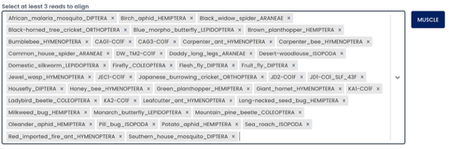
_______ | 23 | Select Auto Trim at the bottom of the alignment. | 
_______ | 24 | Select either PHYLIP ML or PHYLIP NJ to generate the phylogenetic tree. Scroll through the drop-down list to select Tardigrade as the outgroup and click Submit. | 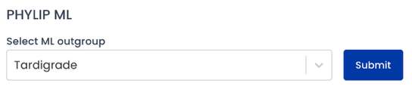
_______ | 25 | Download the tree (PNG format) and save to your lab notebook. Do phylogenetic placements (clades) roughly correlate with taxonomic orders recorded in Table 1?  Optional: Adjust tree visualization using Open Tidy Tree. Modifications include, but are not limited to:  - LEAVES: turn on Leaf Labels.  - BRANCHES: toggle between smooth, square, and straight.  - COLOR: adjust node and branch colors.  Click the teal Download button and save in PNG format for your lab notebook. |   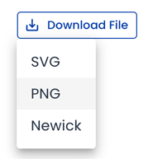
_______ | 26 | Select Dashboard from the main menu (top of page). Your project will appear under My Projects. To make data public, select the circular info button and Change to Public. | 
Screenshots taken from https://dnasubway.org
Proceed to Wolbachia DNA analysis.

_______ | 27 | Under the Projects tab, select Create Project >> Blue Line.
_______ | 28 | Enter a Project Title for the Wolbachia data, select Sequencing Type >> Sanger, and click Create Project >.
_______ | 29 | Under the Import Sequences menu, select Upload From Device.  Navigate to the downloaded files on your Desktop and select the Wolbachia (WSpecF) .ab1 files to be analyzed. Hold the shift key while selecting files to upload multiple sequences. Click Open.
_______ | 30 | Uploaded sequences should now be visible under Project Files. Orange caution symbols indicate files with low QS values; they will not be included in the analysis. | 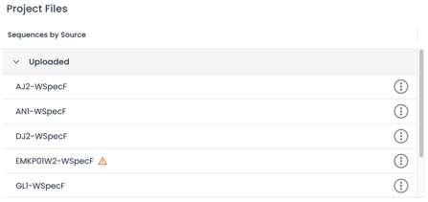  Low-quality sequence
_______ | 31 | Once the files are loaded, click on the first file to view the sequence. This will display the text view of the DNA sequence. Note the N’s at either end of the sequence. These represent low-quality base calls where the sequencer was unable to “call” the base. N=unknown; common at ends of Sanger sequences. | 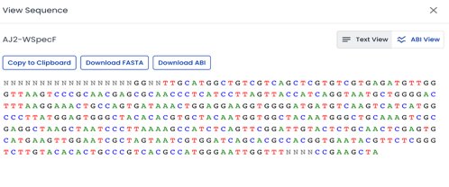  Terminal N’s
_______ | 32 | Select the ABI View button in the upper-right to view the chromatogram (trace file). Use the slider to scroll through the chromatogram. The QS for each base call is highlighted by purple bars above the chromatogram. Bars below the thin blue line are indicative of low-quality base calls.  After viewing the file, click Close. | 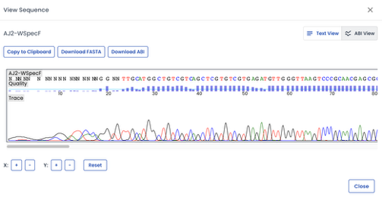  Quality Scores  ABI View
_______ | 33 | Repeat steps 31 & 32 for remaining files. When all sequences have been inspected, select Next Stop. | Screenshots taken from https://dnasubway.org
The next step will trim low-quality ends from the Sanger DNA sequences.
WOLBACHIA DNA Sequences
SELECT: Upload and Review DNA Sequences
EDIT: Trim DNA Sequences
WOLBACHIA DNA Sequences
_______ | 34 | Trim Sequences will trim the undefined N’s and associated low-quality base calls from the ends of each sequence. DNA Subway 2.0 provides two options:  - Auto Trim  - Manual Trim  Option 1: Auto Trim  - Select Auto Trim All to automatically trim all sequences with a single click of the button.  - Optional: You may use the drop-down menu under Manual Trim to view the modified sequences, or you may return to Select >> Project Files to view the trimmed chromatogram.  - If you are satisfied with trimming, select Save Trim and proceed to Step 35. Otherwise, select Revert to Original and proceed with Manual Trim.  Option 2: Manual Trim  - Click on an internal base. This will strike out (trim) all bases leading to that base. The trimmed region will appear in the embedded ABI Viewer for review. Select Save Trim and repeat for all remaining sequences. | 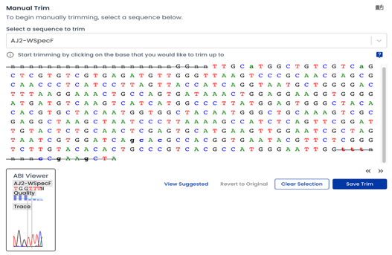  Trimmed bases
_______ | 35 | When the gray All Trims Complete box appears in the upper right-hand corner, click Next Stop to proceed with Analysis.  Note: Most Wolbachia Project sequences are forward (CO1F) direction only. If your class sequenced forward (CO1F) and reverse (CO1R) directions, complete the Pair Sequences and Edit Consensus drop-down tasks to generate consensus sequences.
Screenshots taken from https://dnasubway.org
The next step will use NCBI BLAST to determine taxonomic identification.
ANALYZE - BLASTn: Confirm Taxonomic Identity

WOLBACHIA DNA Sequences
_______ | 36 | Analyze >> BLASTn: Use the drop-down menu to select sequences for BLAST analysis. Click to highlight each sequence and select BLAST.  The program may take ~ 1 minute to compare the selected sequence(s) with a local database of sequences. | 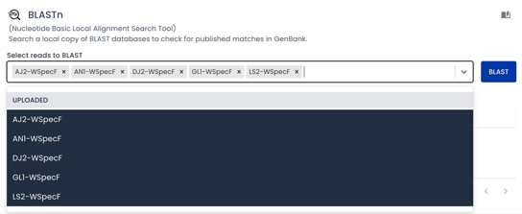  BLAST
_______ | 37 | Select the LinkOut icon to view BLAST results. Are they all listed as Wolbachia, uncultured bacterium, and/or symbiont? | 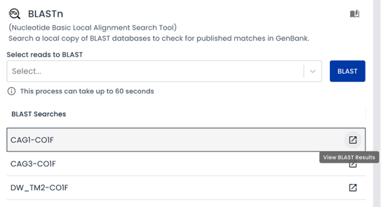
_______ | 38 | Optional: Results are based on DNA Subway’s local copy of reference sequences. BLAST’ing against the complete NCBI database will provide better resolution for Wolbachia sequences.  - Go back to the top of the page. Select >> Project Files and click to open the sequence.  - Select Download FASTA. Save to the desktop.  - Open a new browser window and navigate to NCBI BLAST. https://blast.ncbi.nlm.nih.gov/Blast.cgi  - Select the Nucleotide BLAST box.  - Upload the FASTA file as the Query Sequence. Scroll to the bottom and select the blue BLAST button.  The list of results will include Query coverage, % identity, and links to the nucleotide record. | 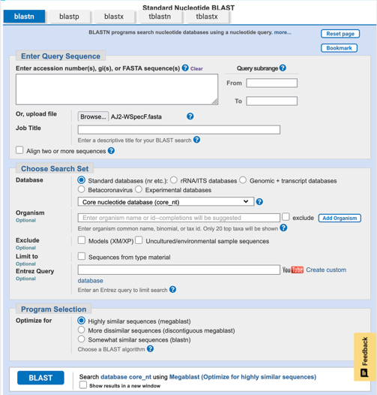  Copy/paste sequence or upload FASTA file  BLAST  #2  #1
_______ | 39 | Record the best BLAST hit of the Wolbachia sequence in Table 2.  Best BLAST hit = __________________________________________________

Screenshots taken from https://dnasubway.org and https://blast.ncbi.nlm.nih.gov.
The next step will build a phylogenetic tree to determine Wolbachia Supergroup designation.

ANALYZE - MUSCLE & PHYLIP: Build a Phylogenetic Tree
WOLBACHIA DNA Sequences
_______ | 40 | Scroll to the top of the page and select Import Sequences >> Upload From Device. Upload the Wolbachia Phylogeny FASTA file (from Step #4). The Wolbachia reference sequences will automatically be added to Project Files.
_______ | 41 | Scroll back to the bottom of the page and click on the Analyze header.
_______ | 42 | Align sequences with MUSCLE:  - Use the drop-down menu to select all sequences from your project files, including the newly added Wolbachia reference sequences. The list is long, keep scrolling until all sequences have been highlighted.  - Click MUSCLE to align all highlighted sequences.  - Scroll through the alignment. If any sequences don’t align well, you may remove the sequence from your selection and press MUSCLE to re-align. | 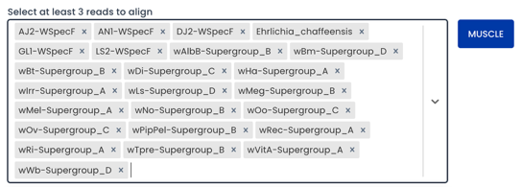
_______ | 43 | Select Auto Trim at the bottom of the alignment.
_______ | 44 | Select either PHYLIP NJ to generate the phylogenetic tree. Scroll through the drop-down list to select Ehrlichia chaffeensis as the outgroup and click Submit. | 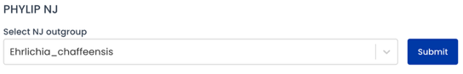
_______ | 45 | Download the tree (PNG format) and save to your lab notebook.  Optional: Click Open Tidy Tree to adjust tree visualization. Modifications include, but are not limited to:  - LEAVES: turn on Leaf Labels.  - BRANCHES: toggle between smooth, square, and straight.  - COLOR: adjust node and branch colors.  Click the teal Download button and save in PNG format for your lab notebook.
_______ | 46 | Based on the clade placement of each Wolbachia sequence, record the predicted Supergroup designation in Table 2.  Wolbachia Supergroup = ___________________________
Screenshots taken from https://dnasubway.org

When finished, delete project files from the Desktop.

Table 1: Arthropod DNA Sequencing Results
SAMPLE ID | QS | PUTATIVE IDENTIFICATION | SCIENTIFIC  NAME | COMMON  NAME | TAXONOMIC ORDER

Table 2: Wolbachia DNA Sequencing Results
SAMPLE ID | QS | ARTHROPOD HOST  IDENTIFICATION  (list N/A if not available) | BEST BLAST HIT | WOLBACHIA SUPERGROUP

