MANAGING THE THREAT:
A Case Study in Wolbachia-Mediated Vector Control

OVERVIEW: Invasive mosquito species are threatening the health and safety of your local community. As members of the Rapid Response Team, your group will represent a key stakeholder in assessing potential risks and developing a coordinated plan of action.

CHALLENGE: Should the community rely on traditional control methods, implement Wolbachia-based strategies, or pursue an integrated approach? Your task is to weigh the trade-offs across health, safety, cost, ecological impact, and public trust to recommend the most effective path forward.

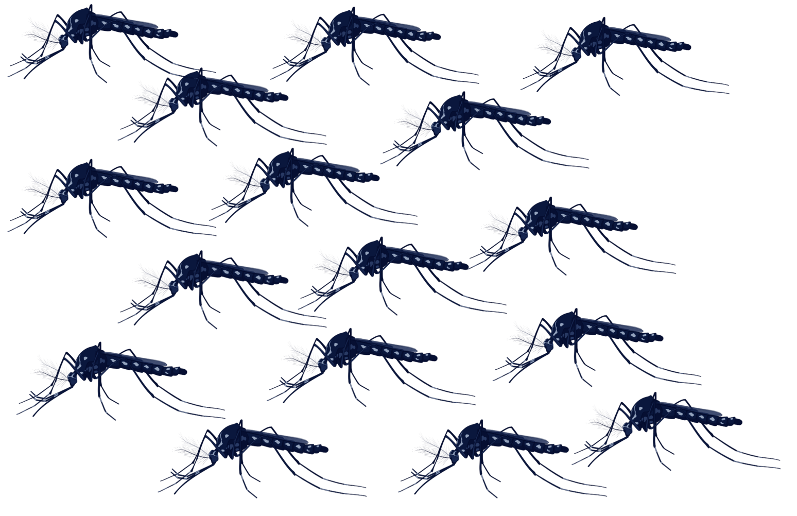
CASE STUDY 2
BACKGROUND 3
Mosquitoes and Vector-Borne Diseases 3
Wolbachia: A New Vector Control Tool 4
ROLE SHEETS 5
Physician (Human Health) 5
Veterinarian (Animal Health & One Health) 6
Entomology Professor (Mosquito Expert) 7
Beekeeper/Environmental Advocate (Pollinator & Ecosystem Health) 8
Cautious Community Member (Skeptic) 9
Chamber of Commerce Representative (Economic Health) 10
INSTRUCTIONS & GRADING RUBRIC 11
SELF-CHECKLIST 12

CASE STUDY

Over the past two months, reports have confirmed an alarming surge of Aedes aegypti and Aedes albopictus mosquitoes—invasive species known to transmit diseases such as dengue, Zika, West Nile, and chikungunya—throughout your community. A young child has just been hospitalized with high fever and severe joint pain, symptoms consistent with dengue fever. Her case, along with several other suspected locally acquired cases, has the entire city on high alert. Concerned parents are demanding that the city use chemical insecticides to eliminate the invasive mosquitoes. In response, your community is assembling a rapid-response team of scientists, healthcare workers, and citizens to evaluate strategies for mosquito control. Among the proposed interventions are two innovative Wolbachia-based approaches: population replacement and population suppression.

TASK





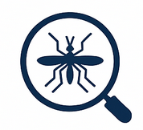
DELIVERABLE
Physician
Focus on patient care and the medical consequences of mosquito-borne diseases.
Veterinarian
Ensure mosquito control strategies safeguard pets, livestock, and wildlife health.
Beekeeper Advocate
Protect pollinators and agriculture from harmful side effects of mosquito control.
Provide expertise on mosquito biology and the effectiveness of control methods.
Cautious Community Member
Represent local concerns, values, and trust issues around biocontrol interventions.
Chamber of Commerce
Advocate for business and economic stability while weighing costs and risks.fchamber

ROLES
Entomology Professor
Your group will present an informed recommendation for how the community should respond to the mosquito threat. Your proposal should be:
- Backed by scientific evidence and incorporate the perspectives of your assigned role, showing how you balanced health, environmental, economic, and social concerns in your decision.
- Creative and convincing in its presentation; 3-5 minutes in length.
Working in an assigned role, your group will:
- Assess the risk of mosquito-borne disease in the community.
- Evaluate potential interventions, including traditional methods like insecticides and breeding-site elimination vs. Wolbachia-based approaches.
- Develop and creatively communicate a recommendation for the community, balancing scientific evidence, ethical concerns, ecological impact, costs, and public opinion.

BACKGROUND

Mosquitoes and Vector-Borne Diseases
Mosquitoes are more than just a nuisance. Responsible for up to 700 million infections and over a million deaths per year, they are considered the deadliest animal on the planet due to their ability to spread diseases from one host to another. The Aedes mosquitoes, particularly Aedes aegypti (yellow fever mosquito) and Aedes albopictus (Asian tiger mosquito), are vectors that spread viruses such as dengue, Zika, chikungunya, yellow fever, and West Nile as well as parasites causing lymphatic filariasis in humans and heartworm in household pets and wildlife. While mosquito-borne diseases are more common in tropical regions, climate change and global travel are increasing the risk of outbreaks in temperate regions, including parts of the United States.

Traditional Vector Control Methods
Public health programs have long relied on traditional mosquito control strategies:
- Insecticide spraying: Provides rapid reductions in mosquito populations but may negatively affect pollinators, other beneficial insects, and human health. Resistance can also develop over time.
- Breeding site elimination: Removing standing water from places like flowerpots, gutters, and tires prevents mosquitoes from laying eggs. Highly effective but requires sustained community participation.
- Mosquito traps & nets: Reduces biting and disease transmission at the household or local level, though their impact at a community-wide scale is more limited.
- Personal protection: Repellents and protective clothing shield individuals from bites but depend on consistent, correct use. They may also be inconvenient and uncomfortable in hot weather.

Emerging Vector Control Methods
An innovative biocontrol strategy is now being deployed in the fight against mosquitoes: Wolbachia! The videos below demonstrate two promising approaches:
- Population replacement: Using Wolbachia to reduce disease transmission.
  - PBS Terra. (2025). Human Footprint: I Visited a Mosquito Factory (S2 Ep2) [Video]. Human Footprint. https://www.youtube.com/watch?v=AI3HE7BcIBk
- Population suppression: Using Wolbachia to crash mosquito populations.
  - HHMI Tangled Bank Studios. (2024). Wild Hope: Birds on the Brink (Episode 17) [Video]. Wild Hope. https://www.wildhope.tv/episode/birds-on-the-brink/

Wolbachia: A New Vector Control Tool
Wolbachia is an obligate, intracellular bacterium that lives inside the cells of its arthropod hosts. It is present in about half of all insects, spiders, mites, and crustaceans worldwide. Passed from mother to offspring, Wolbachia has evolved sophisticated reproductive manipulations – such as male killing, parthenogenesis, feminization, and cytoplasmic incompatibility (where matings between individuals with different infection statuses cause embryonic death) – to enhance its spread. Beyond reproduction, certain strains of Wolbachia, such as wMel from the fruit fly Drosophila melanogaster, block mosquitoes from transmitting RNA viruses. Together, these traits make Wolbachia a powerful new biocontrol tool against mosquito-borne diseases. Two major strategies are under development: population suppression (reducing mosquito numbers) and population replacement (replacing mosquitoes with those that cannot spread disease).

Goal: Shrink the overall mosquito population.
How it Works: Release only male mosquitoes infected with Wolbachia. When they mate with wild females, the eggs do not hatch due to a phenomenon called cytoplasmic incompatibility.
Pros
- Quickly lowers the number of biting mosquitoes.
- Can be highly targeted to specific mosquito species making it a preferred option for invasive species.
Cons
- Requires continuous (costly) releases to keep numbers low.
- An accidental release of females could mitigate the efforts and potentially establish the Wolbachia strain in the population.
POPULATION SUPPRESSION

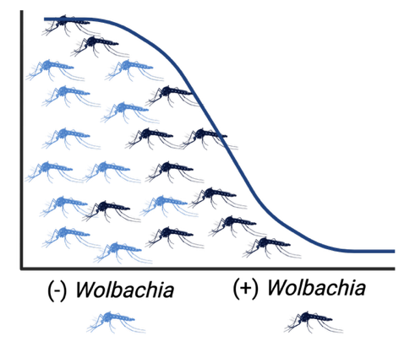

POPULATION REPLACEMENT
Goal: Replace mosquitoes with a population that no longer makes us sick.

How it Works: Release both male and female mosquitoes infected with a strain of Wolbachia that blocks or reduces their ability to transmit viruses. Over time, Wolbachia spreads throughout the population until nearly all mosquitoes are infected.
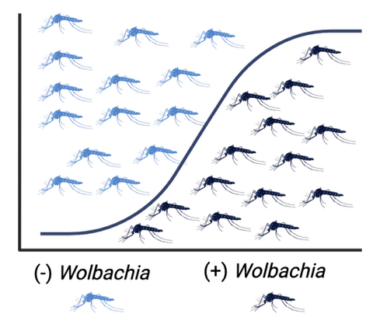
Cons
- Takes time for Wolbachia to spread through the population.
- Requires strong community trust and support.
Pros
- Long-lasting—once Wolbachia spreads, it is sustained in population.
- Reduces disease risk while allowing mosquitoes to remain in the ecosystem/food web.

ROLE SHEETS

Physician (Human Health)

Your primary role is to act as a public health expert, focusing on the immediate and long-term medical implications of a mosquito-borne disease outbreak. You represent the perspective of healthcare professionals and patients in your community. This role may push for urgent, aggressive measures to avoid hospital overload, even if other groups raise concerns about cost, environment, or business impact.

The physician’s key responsibilities are to:
- Assess the medical risk: Analyze the potential for a full-scale epidemic and its impact on the local healthcare system, including hospital capacity, resource allocation, and patient care.
- Evaluate health outcomes: Provide insight into the clinical symptoms, treatment options, and potential long-term health complications (e.g., chronic joint pain from chikungunya, birth defects from Zika) associated with the diseases mentioned.
- Advocate for patient safety: Prioritize interventions proven to reduce disease transmission and protect vulnerable populations, such as children, the elderly, and those with compromised immune systems.

Guided Questions for Consideration
- Which diseases are likely to be transmitted by Aedes aegypti and Aedes albopictus mosquitoes? What are the symptoms and treatment methods, if any, for each disease?
- How might a widespread outbreak like dengue or Zika impact hospital resources, such as emergency room capacity, ICU beds, and medical staff availability?
- From a patient care perspective, what is the trade-off between using rapid, widespread interventions (like insecticides) and more gradual, contained approaches (Wolbachia release)?
- What ethical responsibilities do we have to protect the most vulnerable populations (e.g., young children, the elderly, or pregnant women) from both the disease itself and the potential side effects of the control methods?

Resources
- World Health Organization (WHO)
  - Vector-borne diseases (see Fact Sheets)
  - Dengue global situation
- Dengue Fever in a One Health Perspective: Hospital Disaster Management during Dengue Outbreak
- US Government Accountability Office: Responding to the Zika Outbreak

Veterinarian (Animal Health & One Health)

Your primary role is to advocate for the health and safety of both domestic animals (pets and livestock) and local wildlife, considering how this connects to human health under the “One Health” framework. You represent the perspective that any public health intervention must consider its impact on the entire ecosystem, not just humans. This role may disagree with strategies that pose risks to animals, even if such strategies are intended to protect humans.

The veterinarian’s key responsibilities are to:
- Assess animal health risks: Evaluate the direct threat of mosquito-borne diseases to animals in the community. Discuss diseases like West Nile Virus, which can affect horses and birds, as well as heartworm, which is a significant and potentially fatal threat to dogs and cats. Explore the importance of preventive care like heartworm medication.
- Evaluate the safety of interventions for animals: Research and explain the potential risks that control measures could pose to pets and livestock. For example, some insecticides used for mosquito control could be toxic if ingested by animals, or they might accumulate in the food chain. Consider the potential side effects of widespread Wolbachia release on other insects that are part of the food source for local birds and bats.
- Represent a holistic view of the ecosystem: Bring a perspective that connects human, animal, and environmental health, emphasizing that an unhealthy environment will ultimately lead to an unhealthy community. Convey that a successful mosquito control plan must protect all living creatures, not just people.
Guided Questions for Consideration
- Which mosquito-borne diseases pose the greatest threat to pets and livestock in your community? What are the associated symptoms, treatments, and preventative measures, if any?
- How would a large-scale insecticide spraying campaign potentially affect domestic animals, and what advice would you give pet owners to keep their animals safe during and after the process?
- Considering the food chain, what are the potential long-term risks of insecticide use to local wildlife, such as birds and bats, that prey on insects?
- Are the Wolbachia-based control methods considered safe for animals, and what scientific data or studies would you need to see to be confident in their safety?
Resources
- Mosquitoes: Mosquito-Borne Veterinary Diseases
- PetMD: Insecticide Poisoning in Dogs
- Pesticides: Benefits and Risks of Pesticide Usage in Pets
- National Environment Agency: Wolbachia is Safe and Natural

Entomology Professor (Mosquito Expert)
Your primary role is to provide the scientific and ecological expertise on the invasive mosquito species and the proposed control methods. You represent the perspective of an expert grounded in the biological realities of the situation. This role may advocate strongly for scientific accuracy and caution before large-scale interventions, potentially delaying an immediate public health response.

The entomologist’s key responsibilities are to:
- Provide a scientific foundation: Educate the community on the life cycle, behavior, and habitat of Aedes aegypti and Aedes albopictus. Explain why these specific species are so effective at spreading disease.
- Evaluate control methods: Assess the effectiveness, feasibility, and potential ecological side effects of both traditional and Wolbachia-based strategies. Explain the mechanism of action for each method, highlighting larval versus adult targets and the conditions required for success.
- Consider ecological impact: Evaluate the potential for non-target species—like dragonflies, bats, or other beneficial insects—to be harmed by the interventions, especially insecticides. Consider the long-term effects on the local ecosystem and the potential for mosquitoes to develop resistance to control measures over time.
Guided Questions for Consideration
- What are the key biological characteristics of Aedes aegypti and Aedes albopictus mosquitoes (e.g., life cycle, behavior, morphological identification, breeding habitat, disease transmission)?
- How effective are insecticides compared to Wolbachia-based control? What scientific evidence exists about Wolbachia reducing disease transmission?
- What is the potential for mosquitoes to develop resistance to either the chemical insecticides or the Wolbachia intervention over time?
- If we were to pursue a Wolbachia strategy, what specific scientific data would need to be monitored and collected to ensure the program is working as anticipated and not causing unintended harm?

Resources
- CDC: Mosquitoes
- Penn State Extension: Mosquitoes and Mosquito-Borne Diseases
- EPA: Success in Mosquito Control

Beekeeper/Environmental Advocate (Pollinator & Ecosystem Health)
Your primary role is to act as an advocate for pollinators and the local agricultural ecosystem. You represent the perspective of those concerned about the unintended environmental consequences of large-scale pest control. This role may resist aggressive measures, such as widespread spraying of insecticides, even when public health urgency calls for aggressive interventions.

The beekeeper’s key responsibilities are to:
- Protect pollinators: Ensure that any proposed mosquito control strategy does not harm honeybees or other crucial pollinators, which are vital to the local food system and agricultural economy. Research the specific insecticides being considered, such as pyrethroids, and highlight their documented toxicity to pollinators.
- Advocate for environmentally sound methods: Be skeptical of traditional methods like widespread insecticide spraying, which can be indiscriminate. Consider more targeted, environmentally friendly approaches—such as breeding-site elimination—and evaluate the impact of Wolbachia-based strategies on non-target insects.
- Represent community concerns: Represent the broader environmental and agricultural communities, which have concerns about the use of chemicals in the environment and their impact on everything from flowering plants to family farms. Ensure that economic or health concerns don't overshadow the need for ecological responsibility.

Guided Questions for Consideration
- What specific insecticides are being considered for mosquito control, and what scientific evidence exists regarding their toxicity to honeybees and other pollinators?
- Could introducing Wolbachia affect non-target species or broader ecosystems?
- How do the Wolbachia-based methods compare to traditional strategies in terms of their risk to honeybees and the broader pollinator population?
- What role can the community play in non-chemical prevention, such as breeding-site elimination, and how can this be a more sustainable solution for protecting both public health and pollinators?

Resources
- CNN: Zika spraying kills millions of honeybees
- Michigan State University Extension: Potential impact of mosquito and nuisance insect sprays on pollinators
- Xerces Society for Invertebrate Conservation: The Risk of Pesticides to Pollinators

Cautious Community Member (Skeptic)
Your primary role is to represent the voices of local community members, but your perspective is uniquely shaped by your personal background as a relatively new resident of the area. In your home country of Australia, you witnessed the mixed results and significant controversies surrounding biocontrol efforts, such as the introduction of the cane toad. You are deeply skeptical of new technologies, even if they are more effective.

The cautious community member’s key responsibilities are to:
- Represent public skepticism: Voice the concerns of residents who are wary of government interventions, especially those involving biocontrol, and demand transparency and accountability. Ask tough questions about how Wolbachia could potentially affect other species.
- Draw on relevant historical examples: Highlight well-intentioned and scientifically sound biocontrol projects that led to unforeseen consequences. Consider whether a large-scale Wolbachia release should be avoided, possibly evaluating whether population replacement or population suppression would be safer for the environment.
- Prioritize low-tech solutions: Advocate for simpler, more controllable, and less permanent solutions. Discuss proven methods like breeding-site elimination and public education campaigns compared to expensive and potentially risky innovative interventions.

Guided Questions for Consideration
- Based on historical cases like the Australian cane toad, what are the primary risks associated with releasing a self-replicating biological agent into a new environment?
- If something were to go wrong with the Wolbachia release, is there a way to reverse it? What is the emergency "off-switch," or are we committing to a permanent change in the local ecosystem?
- Are there simpler, less invasive, and more controllable solutions—like community-wide campaigns to eliminate standing water—that we should fully exhaust before we even consider a large-scale, technological intervention?
- How will the proposed intervention(s) affect daily life (e.g., spraying chemicals, changing water use, or releasing mosquitoes)?

Resources
- National Museum Australia: Defining Moments – Introduction of Cane Toads
- Slate: When Humans Play God
- Entomology Today: West Nile Virus Enhanced by Wolbachia in Culex tarsalis Mosquito
- CDC: Integrated Mosquito Management

Chamber of Commerce Representative (Economic Health)

Your primary role is to represent the economic interests of the local community. You are a pragmatist, weighing the costs and benefits of the proposed interventions from a financial and business stability perspective. You need to ensure that the chosen solution is not only effective but also affordable and non-disruptive to the local economy. This role may push back against interventions that limit business activity or bring unwanted media attention, even if such interventions improve public health.
The Chamber of Commerce’s key responsibilities are to:
- Evaluate economic risk and the cost of interventions: Assess the potential financial impact of a prolonged mosquito-borne disease outbreak on local businesses. This includes everything from reduced tourism and customer foot traffic to potential closures and increased healthcare costs for employees. Compare both direct costs (purchasing and deploying insecticides or Wolbachia-infected mosquitoes) and indirect costs (PR campaigns, potential lawsuits, and ongoing monitoring).
- Consider business operations: Weigh how each intervention might affect daily business operations. For instance, widespread fogging could deter customers or require temporary business closures, while a more targeted Wolbachia release might be less disruptive but require a significant upfront investment and the release of large quantities of mosquitoes.
- Advocate for stability: Find a solution that protects public health without crippling the local economy. Argue for a plan that is economically sustainable and maintains the communities’ reputation as a safe and thriving place to live, work, and visit.
Guided Questions for Consideration
- How could a mosquito-borne disease outbreak affect local businesses (restaurants, tourism, outdoor events, agriculture)?
- How much will each control method cost the community?
- What are the public relations implications of each intervention? Could a high-tech solution like Wolbachia be seen as a positive, innovative response, or could the release of millions of mosquitoes cause public backlash that hurts local business?
- Are there ways to turn mosquito control efforts into a positive story (innovation, science leadership, community action) that benefits local business image?
Resources
- IRD: Massive increase in the global economic cost of invasive mosquitoes and the diseases they transmit
- Global Health Now: World Mosquito Day 2025 A New World, Crises, and Opportunities
- Historical Society of Pennsylvania: Diagnosing and Treating Yellow Fever in Phila, 1793
- World Mosquito Program: Sustainable methods to curb the economic toll of mosquito-borne diseases

INSTRUCTIONS & GRADING RUBRIC
Each group should brainstorm the case study from their role’s perspective and form a unified recommendation for the community. Use the Wolbachia videos (page 2) and role-specific resources to jumpstart your research. From your role’s perspective, explore the use of traditional methods - insecticide spraying, breeding site elimination, mosquito traps/nets, personal protection – relative to Wolbachia-mediated vector control. What is the recommended approach to best accommodate your interests?
Each group will deliver a 3–5-minute presentation in the format of their choice. Options include, but are not limited to, PowerPoint presentation, infographic, short essay, video blog, and public service announcement (PSA). Assessments will be based on the following. (Total: 25 points)

1. Role Understanding (5 points)
- Excellent (5 pts): Demonstrates a clear and accurate understanding of the assigned role; uses evidence and reasoning appropriate to that perspective.
- Good (4 pts): Shows general understanding of role, with some minor gaps or simplifications.
- Fair (3 pts): Limited role perspective; reasoning is incomplete or somewhat inaccurate.
- Poor (0–2 pts): Role misunderstood or barely represented.
2. Recommendation Quality (5 points)
- Excellent (5 pts): Final recommendation is well-reasoned, balanced, and reflects multiple perspectives; trade-offs are addressed clearly.
- Good (4 pts): Recommendation is logical and supported but lacks depth or misses some perspectives.
- Fair (3 pts): Recommendation is vague, one-sided, or missing justification.
- Poor (0–2 pts): No clear recommendation or unsupported conclusion.
3. Use of Evidence (5 points)
- Excellent (5 pts): Integrates scientific evidence (mosquito biology, disease risk, Wolbachia research, traditional methods) effectively to support arguments.
- Good (4 pts): Some use of evidence but lacking depth or connections.
- Fair (3 pts): Minimal or superficial evidence; some statements unsubstantiated.
- Poor (0-2 pts): No meaningful evidence used.
4. Communication & Presentation (5 points)
- Excellent (5 pts): Clear, organized, and professional presentation; persuasive and easy to follow.
- Good (4 pts): Mostly clear and organized; minor issues in flow or persuasiveness.
- Fair (3 pts): Somewhat unclear, disorganized, or difficult to follow.
- Poor (0–2 pts): Incoherent or incomplete communication.
5. Collaboration & Discussion (5 points)
- Excellent (5 pts): Actively engages with group members, listens to other perspectives, and contributes constructively to decision-making.
- Good (4 pts): Participates in group discussion and considers other views but could contribute more fully.
- Fair (3 pts): Limited engagement; mostly passive or dominates without collaboration.
- Poor (0–2 pts): Minimal to no participation.

SELF-CHECKLIST

Did I Understand My Role?
- I know what my role is (Physician, Entomologist, etc.).
- I stayed “in character” and thought about the problem from my role’s perspective.

Did We Make a Strong Recommendation?
- Our group made a clear decision about what the community should do, advocating for the values of our specific role.
- We explained the pros and cons of different options.
- We showed that we considered multiple perspectives.

Did We Use Evidence?
- We included facts about mosquitoes, diseases, Wolbachia, or traditional control methods.
- We explained why we supported or rejected different control options.

Did We Communicate Clearly?
- Our presentation was organized and easy to follow.
- We spoke/wrote in a way that made sense to someone outside the group.
- We used evidence and reasoning, not just opinions.

Did I Work Well with My Group?
- I listened to other people’s perspectives.
- I shared my ideas and helped build the final recommendation.
- I respected group members and let everyone have a voice.

Jackson A. Explainer: How climate change is amplifying mosquito-borne diseases. World Mosquito Program. April 22, 2022. https://www.worldmosquitoprogram.org/en/news-stories/stories/explainer-how-climate-change-amplifying-mosquito-borne-diseases
Vector-borne diseases. World Health Organization. September 26, 2024. https://www.who.int/news-room/fact-sheets/detail/vector-borne-diseases
Lymphatic Filariasis. CDC. August 30, 2019. https://www.cdc.gov/dpdx/lymphaticfilariasis/
Dirofilariasis. CDC. June 27, 2019. https://www.cdc.gov/dpdx/dirofilariasis/
Cox D. ‘A warmer, sicker world’: Mosquitoes carrying deadly diseases are on an unstoppable march across the US. BBC. September 26, 2024. https://www.bbc.com/future/article/20240925-why-mosquitoes-are-thriving-in-a-warmer-world

