Wolbachia PCR Protocol - WOLBACHIA
Place a check mark next to each step after you complete it.
__________ Put on laboratory gloves (it is important to use sterile technique).
__________ Carefully disinfect your lab table surface with 70% ethanol solution and paper towels. Spray your gloves with the 70% ethanol solution.
PREPARE PCR MIX
_______ | 1 | Collect a microcentrifuge tube and label it “PCR Mix” | 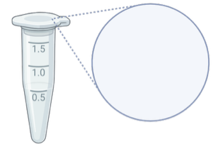  PCR Mix
_______ | 2 | CHANGING TIPS BETWEEN REAGENTS, add each of the following to the PCR Mix microcentrifuge tube. Check off reagents as they are added and discard pipette tips. | 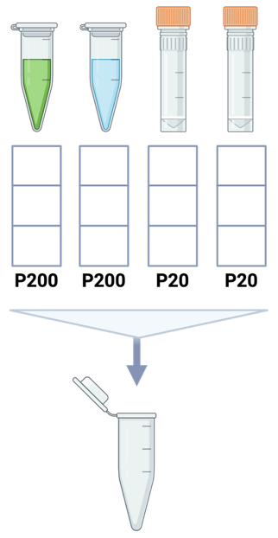  WSpecR  WSpecF  7.5  8  5.5  4  0  4  1  0  4  1  0  Water  Taq  PCR Mix  Change tips  0
   | PCR Mix Reagent | Volume
  ________ | Taq Master Mix, 2X | 87.5 µl
  ________ | PCR Water | 45.5 µl
  ________ | WSpecF (Wolbachia forward) primer | 14 µl
  ________ | WSpecR (Wolbachia reverse) primer | 14 µl
_______ | 3 | The PCR Mix should contain 161 µl total volume. Briefly mix by vortexing and do a quick spin to collect liquid at the bottom of the tube. Make sure the centrifuge rotor is balanced. | 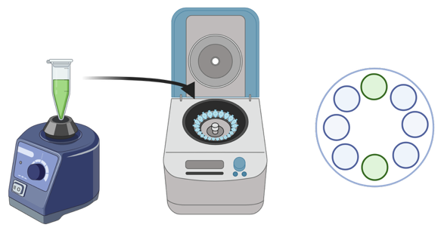  Balance the rotor

Instructions continued on next page

PREPARE PCR REACTION
_______ | 4 | Collect a strip of PCR tubes and label the lids and sides #1-6 with a fine-tipped Sharpie. If using strip tubes, leave the last 2 tubes blank/empty or cut the strip. | 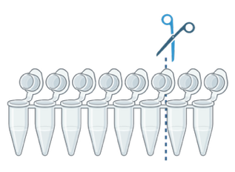  1  2  3  4  5  6
_______ | 5 | Transfer 23 µl PCR Mix to each of the 6 PCR tubes. Use the same pipette tip for all transfers and discard the tip when done. | 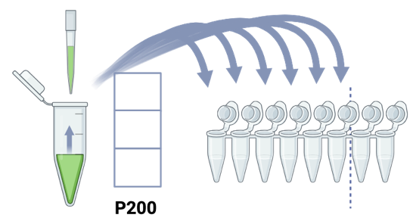  3  PCR Mix  6  5  4  3  2  1  0  2
_______ | 6 | CHANGING TIPS BETWEEN SAMPLES, add 2 µl DNA to its corresponding PCR tube (see table below and check off DNA as it is added). DO NOT LOAD THE SAME DNA INTO ALL TUBES. Each tube will have unique DNA according to the table below. Discard each pipette tip when done and move on to next sample.  Each PCR tube should now contain 25 µl total volume. Gently close each lid. Make sure the lids are closed tightly or the contents will evaporate during the PCR process – but also be sure not to crush your tubes. | 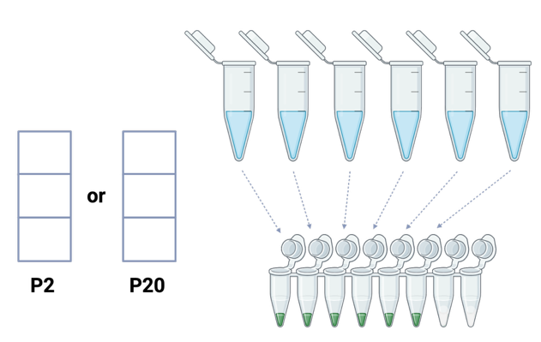  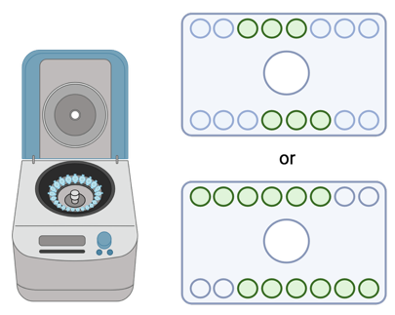  Change tips  2  0  0  0  2  0  1  2  3  4  1  2  3  4  5  6  DNA Tubes  PCR Tubes  (+) DNA  Water
   | PCR Tube | DNA | Instructor Provided
  ____ | 1 | Sample #1
  ____ | 2 | Sample #2
  ____ | 3 | Sample #3
  ____ | 4 | Sample #4
  ____ | 5 | (+) DNA | X
  ____ | 6 | (-) Water | X
_______ | 7 | Spin PCR tubes for 5 seconds to collect all liquid at the bottom of the tubes. Use a centrifuge with a PCR tube rotor and make sure that the rotor is balanced. | Balance the rotor
_______ | 8 | Put your 6 PCR tubes in the thermal cycler and record their placement on the sheet next to the machine. Because all groups use the same labels, it is critical to accurately describe their location.
_______ | 9 | Once all tubes are placed, your instructor will start the PCR program. It will run for ~ 2 hours.
Illustrations created with BioRender.com

Instructions continued on next page

