Wolbachia DNA Extraction Protocol: Part I
Place a check mark next to each step after you complete it.
__________ Turn on the incubator (dry bath or hot water bath) and adjust to 56º C.
__________ Put on laboratory gloves. It is important to use sterile technique throughout this lab activity.
 | Tube Label | Contents
1 |  | Student #1’s arthropod
2 |  | Student #2’s arthropod
3 |  | Positive (+) Arthropod Control
4 |  | Negative (-) Arthropod Control
__________ Carefully disinfect your lab table surface with 70% ethanol solution and paper towels. Spray your gloves with the 70% ethanol solution.
__________ Using a permanent maker (Sharpie), label four microcentrifuge tubes with your combined initials and sample number 1-4 (for example, Paul and Suzie would be: PS1, PS2, PS3, and PS4). Complete the table for your samples and record in your lab notebook.
__________ Obtain the (+) and (-) arthropod controls from your instructor.
SAMPLE PREPARATION

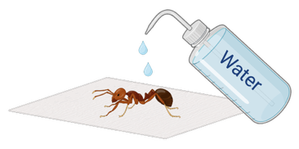
Instructions continued on next page

_______ | 1 | If preserved in alcohol, use tweezers to carefully transfer the first collected arthropod to a paper towel. Rinse with water and blot dry excess liquid.
_______ | 2 | Take a picture of your arthropod. | 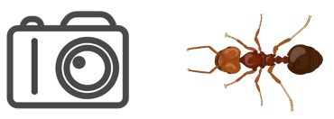
_______ | 3 | FOR SMALL ARTHROPODS: If the specimen is smaller than a grain of rice, use the entire body.  FOR LARGE ARTHROPODS: Use a scalpel or scissors to remove the abdomen and cut off a small piece (roughly ~2 mm). If it has a thick/tough exoskeleton, dissect out the abdominal soft tissue and/or cut into multiple pieces so that the soft tissue is exposed. | 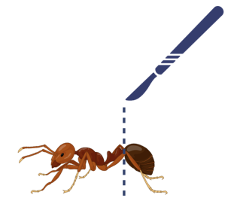  abdomen
_______ | 4 | Place the specimen in the corresponding labeled microcentrifuge tube. Carefully rinse and clean the dissection tools. | 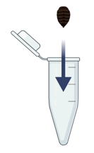  -  1
_______ | 5 | Working with your partner, repeat steps #1-4 for the second arthropod and for the (+) and (-) arthropod controls. Dissections are not necessary for the controls as they are small enough to use the entire body. | 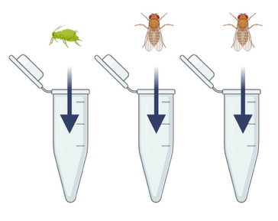  2  3  4  +

CELL LYSIS

*PLEASE NOTE: These techniques are sensitive to errors. If you do not pipette the correct amounts into your tube, you will not get results. Double check your pipette volumes!
Instructions continued on next page

SAMPLE PREPARATION

_______ | 6 | Add 180 µL Buffer ATL to the tube containing your first arthropod and discard the tip. Use a sterile pestle to thoroughly grind the sample for about a minute. Ensure that the pestle is tightly pressed against the tube and apply muscle power to homogenize the sample. Remove the pestle and place on a paper towel. | 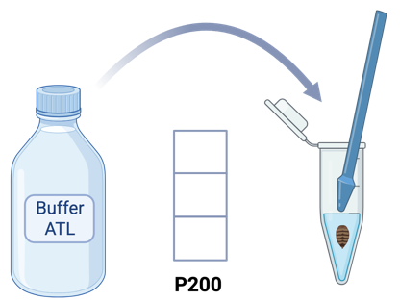  0  1  8  1
_______ | 7 | Using a new pipette tip and new pestle for each sample, repeat the above step with remaining arthropods. | 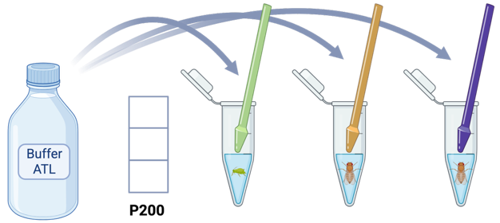  Change tips  2  1  0  8  4  3
_______ | 8 | Using new pipette tips for each sample, add 20 µL proteinase K to each of the microcentrifuge tubes. | 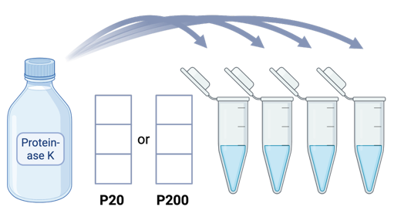  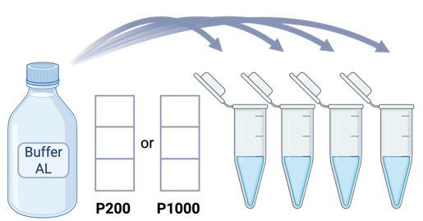  2  0  0  0  0  2  Change tips
_______ | 9 | Using new pipette tips for each sample, add 200 µL Buffer AL to each of the microcentrifuge tubes. | 2  0  0  0  2  0  Change tips
_______ | 10 | Immediately mix each tube by vortexing for 10 seconds. | 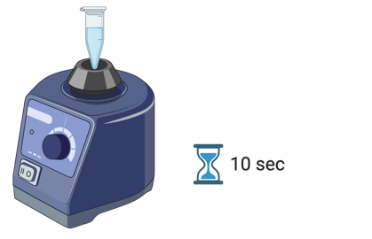  10 sec
_______ | 11 | Place your tubes in the incubator where they will incubate at 56º C for at least 15 minutes. | 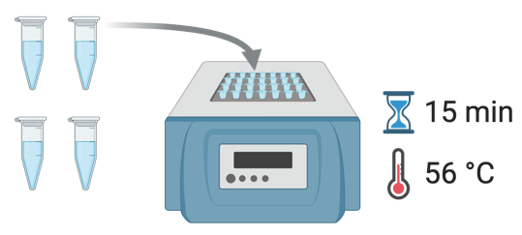  15 min  56 °C
_______ | 12 | While the tubes are incubating, label four new microcentrifuge tubes using the same labels as above. | 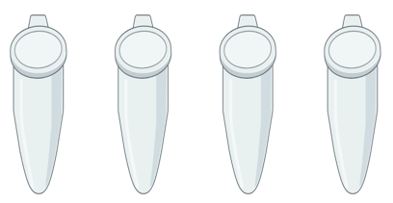  4  3  2  1
_______ | 13 | Collect tubes from the incubator and spin in the centrifuge for about 30 seconds at 8000 rpm to pellet debris. Ensure that the rotor is balanced and centrifuge lids are properly secured (if applicable). Confirm with your instructor before your first spin. DNA is now in the supernatant (the clear liquid above the debris pellet). | 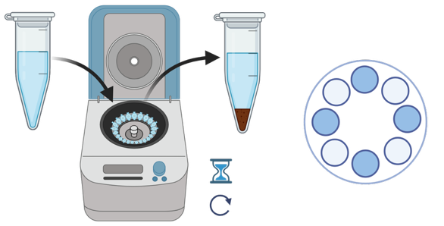  Supernatant  Balance the rotor  8000 rpm  30 sec
DNA PRECIPITATION

_______ | 14 | NOTE: This step requires patience and care! Carefully pipette or pour the supernatant from each arthropod tube to the newly labeled microcentrifuge tube with corresponding label. Do not dislodge the pellet. If needed, re-spin the sample and use a P1000 pipette to transfer the supernatant (less than 400 µL; some liquid will remain in the tube). | 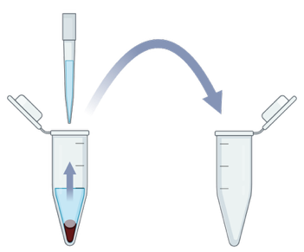  Do not transfer the pellet
_______ | 15 | Discard debris pellet tubes and keep the supernatant tubes – this is where your DNA is located. | 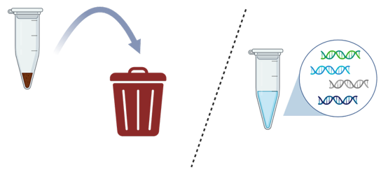  Discard  Keep
_______ | 15 | Using new pipette tips for each sample, add 200 µL Ethanol to each of the supernatant-containing microcentrifuge tubes. | 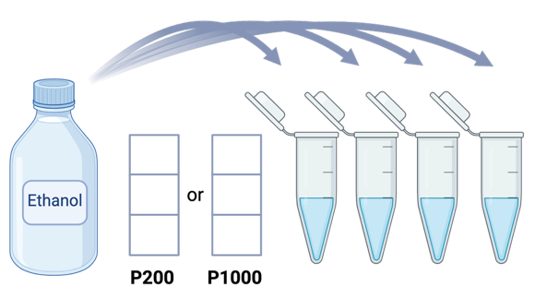  0  0  2  2  0  0  Change tips
_______ | 16 | Immediately mix each tube by vortexing for 10 seconds. DNA is now precipitated. | 10 sec
Optional stopping point. Precipitated DNA may be stored in the refrigerator (4º C).

Wolbachia DNA Extraction Protocol: Part II
Place a check mark next to each step after you complete it.
__________ Put on laboratory gloves (it is important to use sterile technique).
__________ Carefully disinfect your lab table surface with 70% ethanol solution and paper towels. Spray your gloves with the 70% ethanol solution.
DNA PURIFICATION: BINDING DNA TO THE MEMBRANE

_______ | 1 | Collect four Spin Columns fitted with four Flow Through tubes. Label the lids of the Spin Columns with your sample numbers from Part I.  *NOTE: The Spin Column sits inside the Flow Through tubes. DO NOT SEPARATE the Spin Column from the Flow Through tube. | 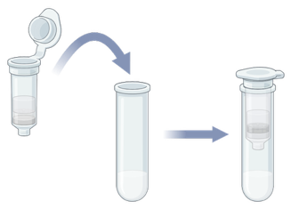  * Pre-assembled in the kit  Spin Column
_______ | 2 | Carefully pour or pipette the liquid from your first sample (total volume ~600 µL; include any solid precipitate at the bottom of the tube) into the corresponding Spin Column. Repeat this process with the three other tubes, keeping the tube numbers consistent.  *BE CAREFUL TO NOT PUNCTURE THE MEMBRANE IN THE SPIN COLUMN | 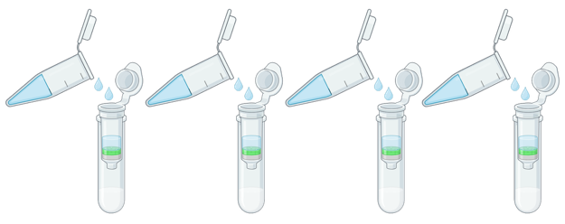  4  1  2  3  Flow Through tube
_______ | 3 | Place your tubes in the centrifuge and spin for 1 minute at 8000 rpm. DNA is now bound to the Spin Column membrane. | 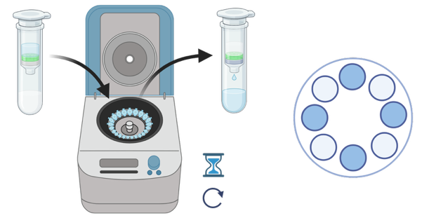  Balance the rotor  1 min  8000 rpm
_______ | 4 | Discard liquid from the bottom of each Flow Through tube onto a paper towel (you will reuse this towel). Place the Spin Columns back in the same Flow Through tubes. | 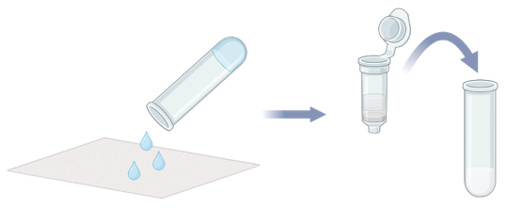
DNA PURIFICATION: WASHING THE DNA
Instructions continued on next page

Change tips
_______ | 5 | Using new pipette tips for each sample, add 500 µL Buffer AW1 to each Spin Column. Use caution to not touch the white membrane with your pipette tips. | 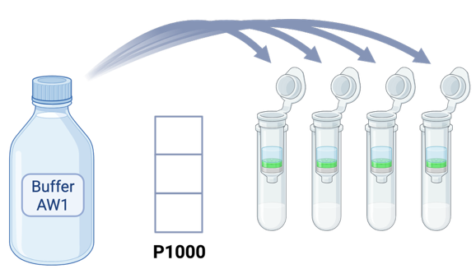  4  0  5  0  1  2  3

_______ | 6 | Place your tubes in the centrifuge and spin for 1 minute at 8000 rpm. | Balance the rotor  1 min  8000 rpm
_______ | 7 | Discard liquid from the bottom of each Flow Through tube onto a paper towel. Place the Spin Columns back in the same Flow Through tubes and discard the paper towel. | 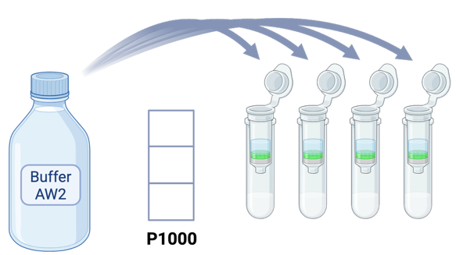
_______ | 8 | Using new pipette tips for each sample, add 500 µL Buffer AW2 to each Spin Column. Use caution to not touch the white membrane with your pipette tips. | 4  3  2  1  0  5  0  Change tips
_______ | 9 | Place your tubes in the centrifuge and spin for 3 minutes at 14,000 rpm. | 3 min  14,000 rpm  Balance the rotor
_______ | 10 | Discard Flow Through tubes and keep the spin column – this is where your DNA is located. | 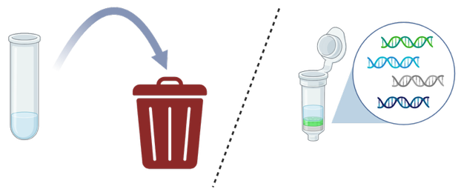  Discard  Keep
DNA ELUTION

_______ | 11 | Collect four new microcentrifuge tubes and label the lids AND sides of the tubes with your sample numbers. | 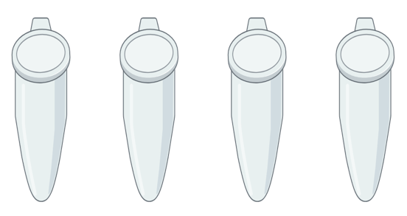  3  2  4  1  1  2  4  3
Instructions continued on next page

_______ | 12 | Place your spin columns into the corresponding microcentrifuge tubes (note: you will not be able to close the microcentrifuge tube lid). | 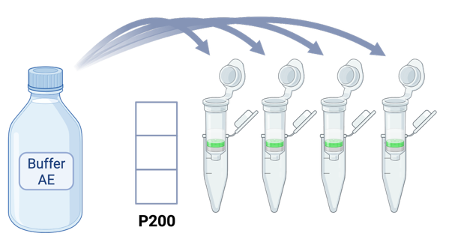  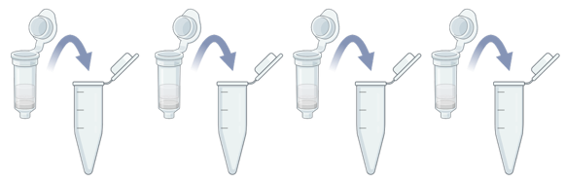  4  3  2  1
_______ | 13 | Using new pipette tips for each sample, add 100 µL Buffer AE directly to the white membrane in each spin column. Use caution to not touch the membrane with your pipette tips. | 1  0  0  Change tips
_______ | 14 | Let your tubes sit at room temperature for 1 minute. | 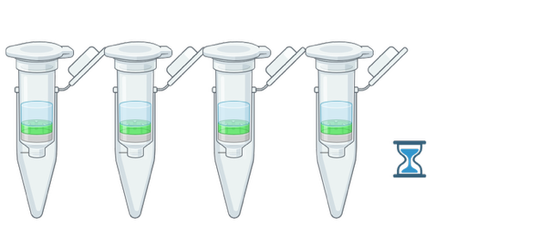  1 min
_______ | 15 | Place your tubes in the centrifuge and spin for 1 minute at 8000 rpm. This will pull DNA through the Spin Column and into the microcentrifuge tubes. | 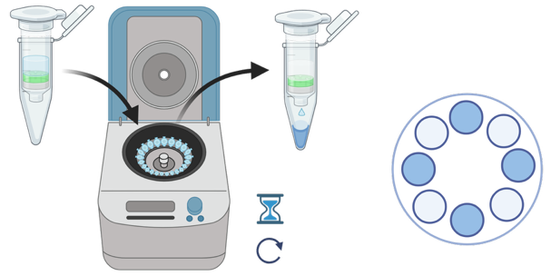  1 min  8000 rpm  Balance the rotor
_______ | 16 | Discard the Spin Columns. Keep the microcentrifuge tubes – this is where the DNA is located. | 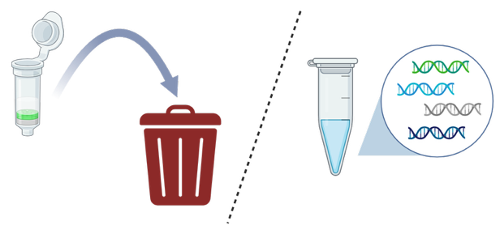  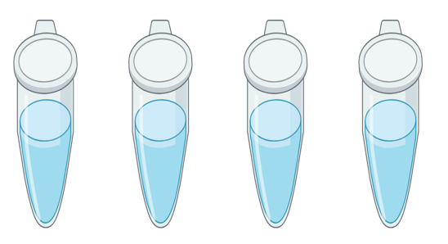  Keep  Discard
_______ | 17 | Make sure your final microcentrifuge tubes are clearly labeled both on the top and on the side with your initials and sample number. If any of the lids snapped off during the final spin, transfer DNA to a new labeled tube. | 3  2  4  1  1  2  4  3
Illustrations created with BioRender.com
Place DNA tubes in a storage box. Label the box with colored lab tape, create an organized record of the contents, and store the DNA box in the freezer (-20º C).

