Video Club
Adaptation | Native species | Selective pressure
Ecosystem | Parasite | Vector
Invasive species | Speciation
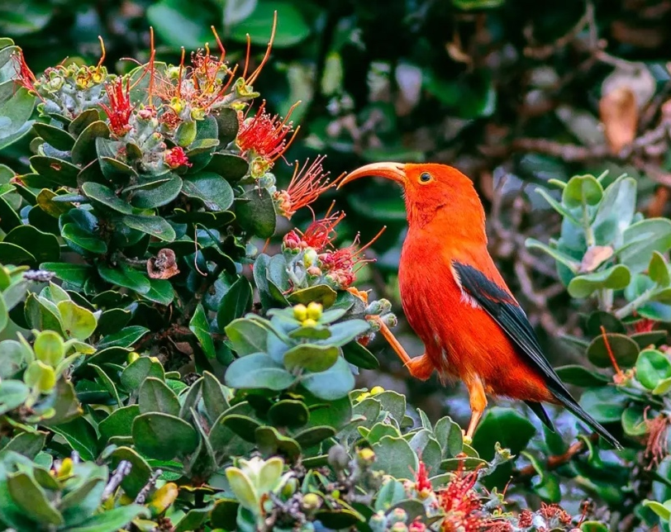
Video Resource
Birds on the Brink: Is there hope for Hawaii’s endangered honeycreepers?

Video Producers
WILD HOPE | HHMI Tangled Bank Studios

Video Club activity prepared by Dina Constantinides & Sarah Bordenstein. The Wolbachia Project - and this Video Club activity - are not affiliated with the producers of this video.

Image: Hawaiian honeycreeper on a ‘ōhi‘a lehua tree at Hakalau Forest National Wildlife Refuge in Hawaii.
Title

Wolbachia & Hawaii’s Honeycreepers
- ______________________: A community of interacting organisms and their physical environment.
- ______________________: The process by which new species form.
- ______________________: An inherited characteristic that helps an organism survive and/or reproduce in a certain environment.
- ______________________: An environmental factor that influences the survival and reproduction of organisms. It can lead to changes in the traits of a population over time.
- ______________________: An organism that naturally occurs in a specific region or ecosystem.
- ______________________: An organism that is not indigenous, or native, to a specific area and whose introduction causes (or is likely to cause) economic or environmental harm, or harm to human, animal or plant health.
- ______________________: An organism that lives in or on another organism at the expense of the host.
- ______________________: An organism that transmits a disease, or disease-causing agent, from one host to another.
BEFORE THE VIDEO
Match the following terms with their definitions.

VIDEO ACCESS
https://www.wildhope.tv/episode/birds-on-the-brink/

Image available via public domain, USFWS

Watch the video and discuss the following questions with your class.

Wolbachia-mediated Mosquito Management
Termed Incompatible Insect Technique (IIT), multiple global initiatives are testing the release of Wolbachia-mosquitoes to selectively crash populations of harmful, invasive mosquitoes.

Debug Fresno is a US-based field study led by the biotech company Verily. Partnering with MosquitoMate, Debug Fresno successfully reduced the population of invasive Aedes aegypti mosquitoes in Fresno, CA. Learn more about their approach here: https://debug.com/how/.

INTRO
- How might the loss of honeycreepers impact the Hawaiian ecosystem?

EVOLUTION OF HONEYCREEPERS
- Name three types of adaptations among honeycreeper species.
- Highlighting one adaptation above, how might a selective pressure have led to its evolution in honeycreepers?

EXTINCTIONS
- Name three factors that have contributed to the endangerment of the Hawaiian honeycreeper.
- Why were mongooses introduced to Hawai’i and how did their introduction impact bird species?
- Why might high speciation make birds less resilient in the face of stressors like land loss and the introduction of invasive species?

RESTORATION
- How does restoring native trees help to save endangered birds?

REINTRODUCTION
- How do scientists know which species used to live on a particular island?

AVIAN MALARIA
- What is avian malaria and how is it spread?

MOSQUITO CONTROL
- How might releasing male mosquitoes with a different strain of Wolbachia help to control the spread of avian malaria?
- Which mosquitoes bite and spread disease, male or female?

CONCLUSION
- Would you support the release of Wolbachia-mosquitoes? Why or why not?

Graphic Illustration

Create a graphic illustration to accompany this video.
Graphic illustrations capture the interest of readers and concisely summarize a key finding of the research. They often accompany journal publications and news releases to highlight main take-home messages.
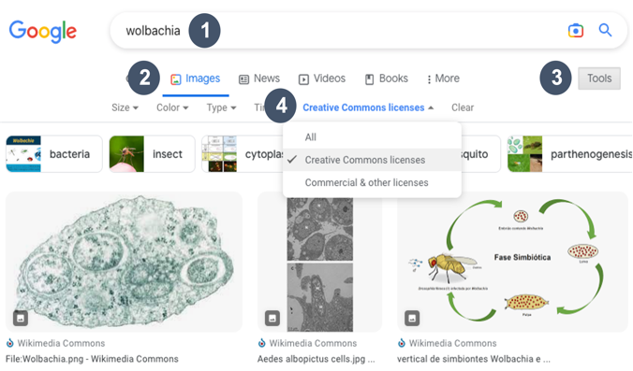
If using images from the internet, pay attention to copyright restrictions and include proper citations.
Other Resources for Free Images
NIH BioArt: https://bioart.niaid.nih.gov
Wikimedia Commons: https://commons.wikimedia.org
UMCES: https://ian.umces.edu/media-library/symbols/
Vecteezy: https://www.vecteezy.com
PhyloPic: https://beta.phylopic.org
Openverse: https://wordpress.org/openverse
Flaticon: https://www.flaticon.com
Bioicons: https://bioicons.com

#1 – EVOLUTION OF HAWAIIAN HONEYCREEPERS
The video discusses the origin and evolution of Hawaiian honeycreepers. Provide a summary illustration and/or highlight a specific adaptation.

#2 – EXTINCTION OF HAWAIIAN HONEYCREEPERS
The video discusses several contributing factors to the disappearance of Hawaii’s honeycreepers. Illustrate a summary of the factors or detail a specific cause.

#3 – WOLBACHIA-MEDIATED MOSQUITO MANAGEMENT
Create an illustrated overview of Wolbachia-mediated mosquito control.

Create an illustration for one of the following topics:
- Enter a keyword @ https://www.google.com
- From the main results page, select Images
- From the image results page, select Tools
- Select Usage Rights >> Creative Commons License

Google Search for CC Images
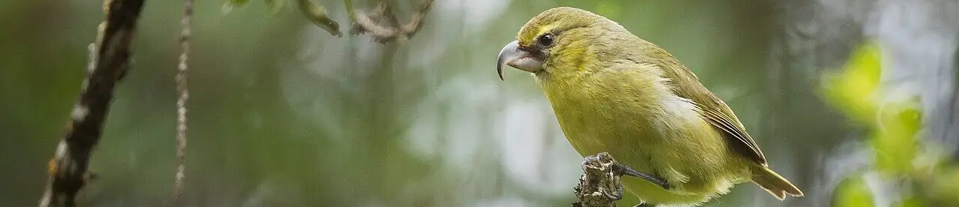
What is the current status of Wolbachia-mediated mosquito management in Hawai’i?

Claim:

Evidence:

Reasoning:

Current Events

RESEARCH. Summarize the status of Hawaiian honeycreeper conservation using online news articles, videos, and publications. The following resources can help you get started:
- https://www.birdsnotmosquitoes.org/
- https://www.npr.org/2024/06/12/nx-s1-4906582/mosquito-hawaii-birds-endangered-species-extinct
- https://www.nps.gov/articles/the-time-is-now-saving-maui-s-honeycreepers-before-it-is-too-late.htm

Image of the kiwikiu, or Maui Parrotbill, by Zach Pezzillo, Maui Forest Bird Recovery Project. Made available under CC BY-SA 4.0 license.



