**Journal Club**

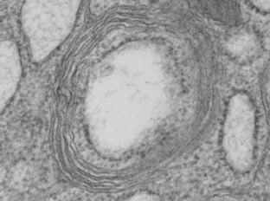

**Authors**

Marshall Hertig

S. Burt Wolbach

**Publication**

*Journal of Medical Research*

March 1924

Vol 44; No 3

Pages 329-374.7

**Access**

<https://www.ncbi.nlm.nih.gov/pmc/articles/PMC2041761/>

Journal Club prepared by Sarah Bordenstein.

*Image of a* Wolbachia *cell surrounded by multiple insect-derived membranes. Transmission electron micrograph taken by Sarah Bordenstein. CC-BY-NC-ND.*

**BACKGROUND RESEARCH**

1. What is the causative agent of Rocky Mountain spotted fever?
2. How is Rocky Mountain spotted fever transmitted?
3. What are sheep keds?
4. What is meant by “Gram-negative” bacteria?
5. *Rickettsia* and *Wolbachia* are both members of which taxonomic order?
6. What is the common name for *Culex pipiens?*

*Read the journal article and discuss the following questions with your class.*

**INTRODUCTION** (pages 329-330)

1. Which types of microorganisms were generally described as *Rickettsia*?
2. Based on the authors’ observations, what was the perceived distribution of *Rickettsia*?
3. What was the purpose of this study?

**MATERIALS AND TECHNIQUE** (pages 331-335)

1. Which type of microscope was used?
2. Why did the authors prefer smears rather than sections?
3. List and describe four criteria used to distinguish rickettsiae from cell granules and other artefacts.

**Title**

Studies on Rickettsia-like Micro-organisms

in Insects

*Wolbachia*

**In 1924, entomologist Marshall Hertig (1893-1978) and pathologist S. Burt Wolbach (1880-1954) first observed *Wolbachia* within the reproductive organs of *Culex pipiens* (Figures 4-9). Twelve years later, Hertig would officially describe and name the genus *Wolbachia* after his colleague.**

**Hertig M. The Rickettsia, *Wolbachia pipientis* (gen. et sp.n.) and Associated Inclusions of the Mosquito, *Culex pipiens*. *Parasitology*. 1936;28(4):453-486. doi:10.1017/S0031182000022666**

**OBSERVATIONS ON VARIOUS RICKETTSIAE**

***Rickettsia melophagi in the Sheep-Ked Melophagus ovinus*** *(pages 335-340)*

1. List at least three observations that support the hereditary transmission of Rickettsia-like microorganisms. (page 336)
2. What definitive characteristic of rickettsiae was observed by Nöller in 1917 and Jungmann in 1918? (page 336)
3. What was meant by the following statement? (page 337)

“We also experienced no untoward results from allowing the keds to feed upon our persons.”

1. Describe the dispute between Woodcock and others regarding the nature of rickettsiae. (pages 338-340)

***Rickettsia in the Mosquito, Culex pipiens*** *(pages 340-344)*

1. The authors collected and dissected *Culex pipiens* mosquitoes from Boston and Minneapolis. What did they observe in all 25 individuals?
2. In which organs did they constantly observe this microorganism?
3. Describe the observed morphology of this microorganism.

**DISCUSSION**

1. What was the general description of intracellular symbionts? (page 361)
2. What was Cowdry’s definition of *Rickettsia*? (page 363)
3. Which characteristics were reportedly missing from Cowdry’s definition? (page 363)
4. In conclusion, what was the proposed description of *Rickettsia*? (page 366)

**REFLECTION**

1. Prior to the internet, how did scientists stay up to date with new discoveries?
2. Discuss modern-day tools/techniques that would facilitate the discovery and description of new microbes.
3. Isaac Newton famously stated, “If I have seen further it is by standing on the shoulders of Giants.” This phrase has become a metaphor to symbolize scientific progress by building upon the discoveries of others.
4. List one example from the article in which the authors built upon previous observations.
5. List one example from the article in which the authors disputed previous conclusions.
6. How are both of these examples important to the advancement of science and our understanding of the natural world?

**Graphic Illustration**

***Create a graphic illustration to accompany this research article.***

Graphic illustrations capture the interest of readers and concisely summarize a key finding of the research. They often accompany journal publications and news releases to highlight main take-home messages.

**#1 – DEVELOPMENTAL CYCLE** (Page 343)

The authors describe a tentative cycle of development for the Rickettsia-like microorganisms with respect to their mosquito host (egg 🡪 larvae 🡪 pupae 🡪 adult).

**#2 - DESCRIPTION OF *RICKETTSIA*** (Page 366)

The authors propose a revised description of *Rickettsia* based on cumulative evidence provided in the article.

**#3 – TIMELINE OF EVENTS**

Create an illustrated timeline to place the results of this paper in context of other scientific discoveries, world events, etc.

Create an illustration for one of the following topics:

1. Enter a keyword @ <https://www.google.com>
2. From the main results page, select **Images**
3. From the image results page, select **Tools**
4. Select **Usage Rights** >> **Creative Commons License**

**Google Search for CC Images**

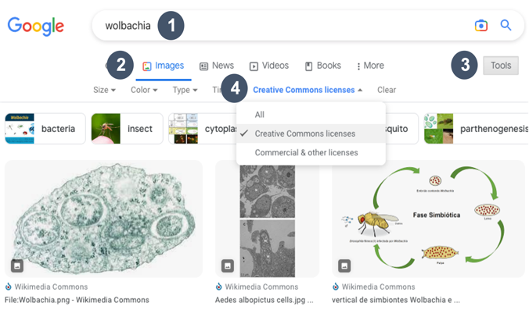

If using images from the internet, pay attention to copyright restrictions and include proper citations.

**Other Resources for Free Images**

Wikimedia Commons: <https://commons.wikimedia.org>

Vecteezy: <https://www.vecteezy.com>

PhyloPic: <https://beta.phylopic.org>

Openverse: <https://wordpress.org/openverse>

Flaticon: <https://www.flaticon.com>

Bioicons: <https://bioicons.com>

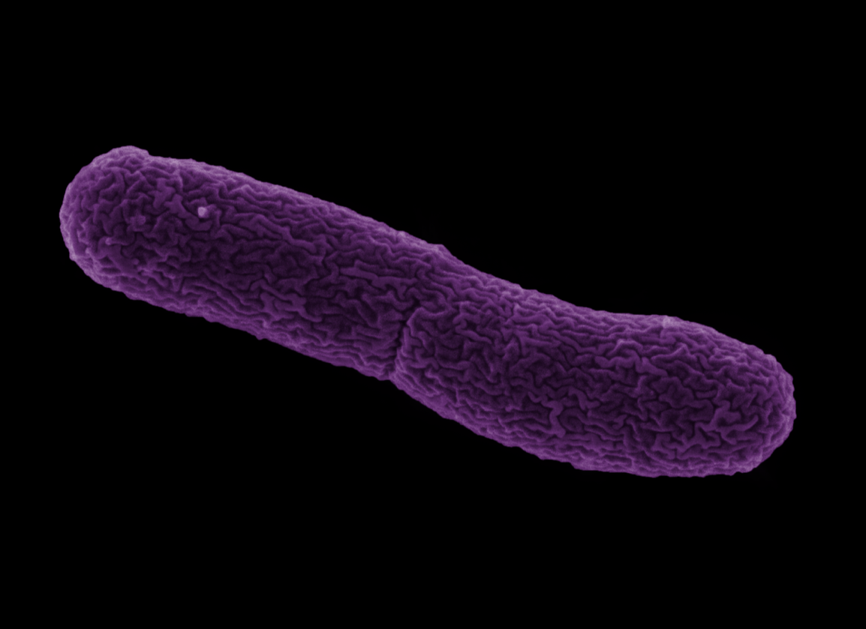

*Wolbachia pipientis*

Claim • Evidence • Reasoning

*Review Figures 4-9 at the end of the article:*

**What were the entities observed in Giemsa smears of *Culex pipiens* gonads?**

**Claim:**

**Evidence:**

**Reasoning:**

**CLAIM:** Write a sentence describing the observations from *Culex pipiens* smears.

**EVIDENCE:** Provide scientific data to support your claim. Use evidence presented on pages 340-343 of the article.

**REASONING:** Describe why/how the evidence supports the claim. Use criteria presented on pages 333-335 and throughout the manuscript.

Scanning electron micrograph of *Wolbachia pipientis*. Image taken by Dennis Kunkel and colorized by Robert Brucker; sample purification and fixation by Sarah Bordenstein. Image under copyright.

