I’ve
Updated: February 2023

Introduction to Wolbachia

Wolbachia & Reproductive Parasitism

Project Guide

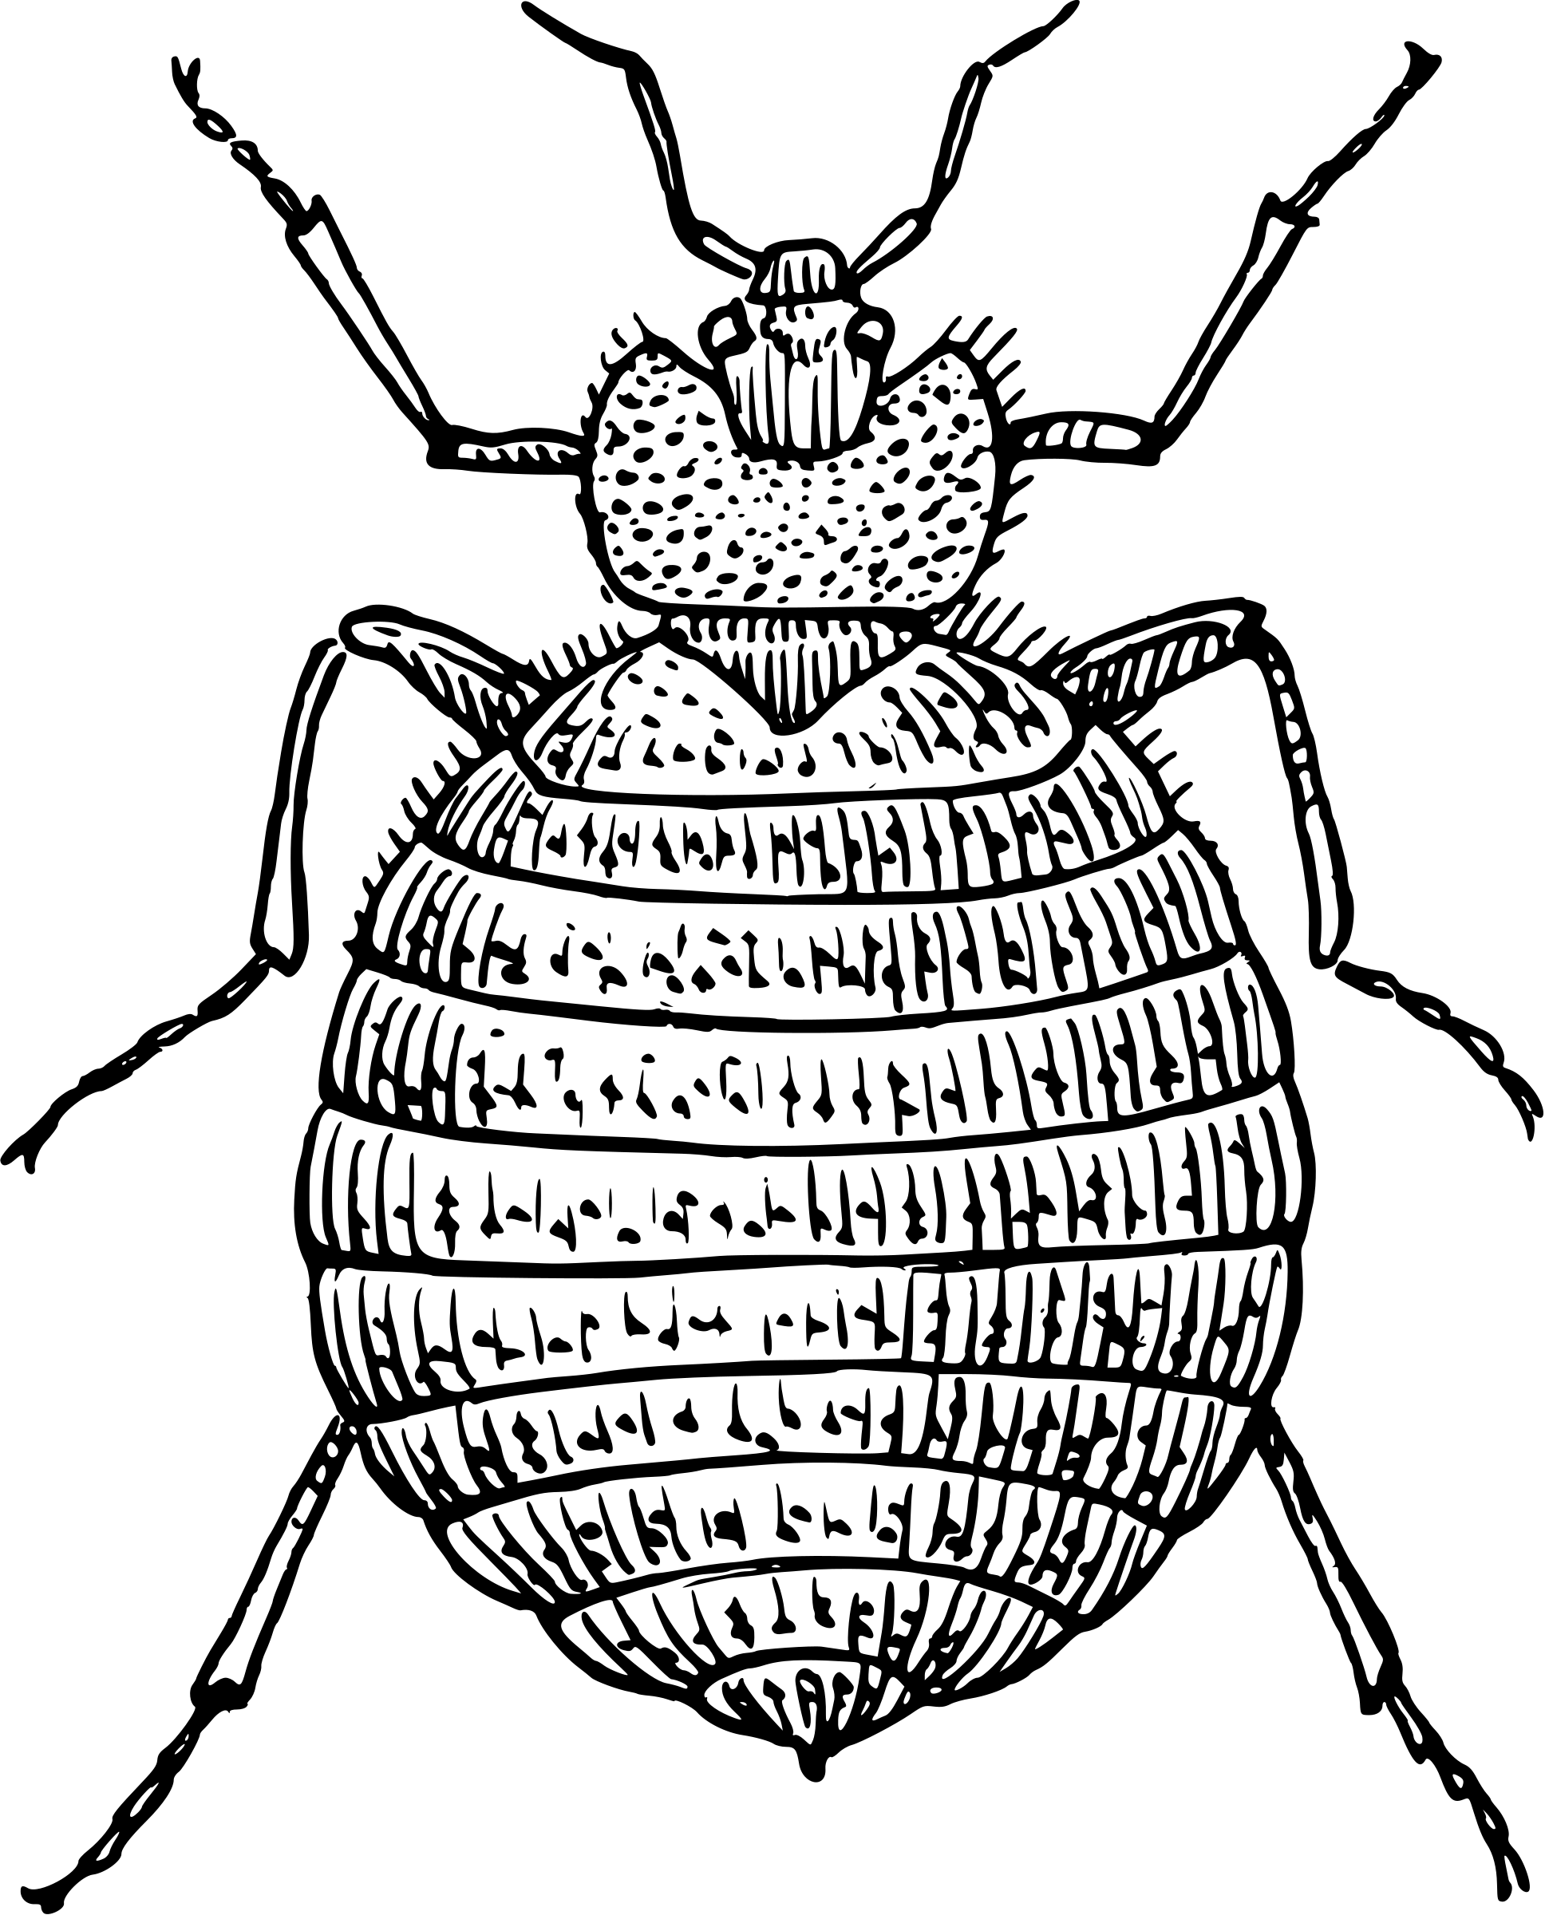

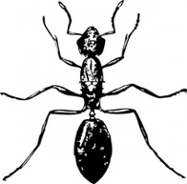
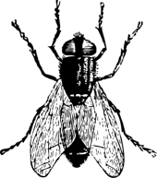
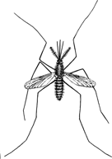
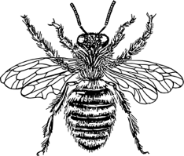
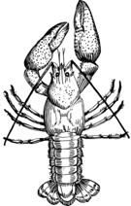

The Wolbachia Project

Page | Contents
3-4 | Introduction to Reproductive Parasitism
5-7 | Introduction to Cytoplasmic Incompatibility (CI)
8 | Figures A & B
9 | Student Notes
10 | Word Search
11 | Glossary

Content is made available under the Creative Commons Attribution-NonCommercial-No Derivatives International License. Contact (info@wolbachiaproject.org) if you would like to make adaptations for distribution beyond the classroom.


The Wolbachia Project: Discover the Microbes Within! was developed by a collaboration of scientists, educators, and outreach specialists. It is directed by the Bordenstein Lab.

https://www.wolbachiaproject.org

The word search was created with
The Teacher’s Corner at:
https://www.theteacherscorner.net

Introduction to Reproductive Parasitism

Recommended Background Video

I Contain Multitudes: Mosquitoes Might SAVE Lives, Thanks To Bacteria
https://www.pbs.org/video/mosquitoes-might-save-lives-thanks-to-bacteria-ufusya/

From PBS Digital Studios, Ed Yong talks with Dr. Scott O’Neill about the use of Wolbachia to combat mosquito-borne diseases. This 9-minute video introduces Wolbachia-induced reproductive parasitism and discusses Wolbachia’s ability to block the transmission of viruses.

Class Activity

Work with your class or in a group to complete Figure A (page 8) and answer the questions below.

For the purpose of this activity, assume that the average clutch size for uninfected individuals is 10 with an even distribution of 5 females and 5 males.

Yellow fever mosquitoes are usually uninfected; therefore, their offspring develop normally.
- FIGURE A: Record the number of male and female offspring. Label the phenotype.
- DISCUSSION QUESTION: If scientists want to study Wolbachia-infected individuals and need negative controls, how could they make them uninfected? (Hint: How are bacterial infections treated?) ______________________________________________________________________
______________________________________________________________________________
______________________________________________________________________________

In ladybugs, or lady beetles, Wolbachia can induce male killing. In this case, male offspring do not survive.
- FIGURE A: Record the number of male and female offspring. Label the phenotype.
- DISCUSSION QUESTION: Wolbachia-induced male killing could lead to extinction of its arthropod host. Alternatively, how might it benefit the host? (Hint: Refer to the introduction of this paper for guidance - https://doi.org/10.1371/journal.ppat.1007936)
______________________________________________________________________________
______________________________________________________________________________
______________________________________________________________________________

In roly polies, or pill bugs, Wolbachia can induce feminization. In this case, genotypic males develop into phenotypic females.
- FIGURE A: Record the number of male and female offspring. Label the phenotype.
- DISCUSSION QUESTION: What is the difference between genotype and phenotype?
______________________________________________________________________________
______________________________________________________________________________
______________________________________________________________________________

In clover mites, a type of spider mite, Wolbachia can induce parthenogenesis. In this case, females can produce daughters without mating.
- FIGURE A: Record the number of male and female offspring. Label the phenotype.
- DISCUSSION QUESTION: What is a disadvantage of parthenogenesis (and asexual reproduction, in general)? ______________________________________________________________________
______________________________________________________________________________
______________________________________________________________________________

Figure A Summary Questions

- Review the results. What is the impact of Wolbachia on these arthropod hosts?
______________________________________________________________________________
______________________________________________________________________________
______________________________________________________________________________

- Why might Wolbachia prefer, or select for, females? (Hint: How are mitochondria inherited?)
______________________________________________________________________________
______________________________________________________________________________
______________________________________________________________________________

- Wolbachia are obligate intracellular endosymbionts, which means they live within the cells of other organisms. Based on the host interactions described above, in which body system would you expect to find Wolbachia?
______________________________________________________________________________
______________________________________________________________________________
______________________________________________________________________________

Introduction to Cytoplasmic Incompatibility (CI)

Recommended Background Video

Cytoplasmic Incompatibility Genes and Applications
https://youtu.be/tgUFKHm0eu4

From NSF Science Now, Dr. Seth Bordenstein discusses cytoplasmic incompatibility and the potential use of Wolbachia to control the spread of insect-borne diseases and agricultural pests.

Class Activity

A fourth type of reproductive parasitism is called cytoplasmic incompatibility (CI). Work with your class or in a group to answer the questions below.

Empty circle = Wolbachia-uninfected
Filled circle = Wolbachia-infected






Wolbachia (+)
Infected male
Wolbachia (-)
Uninfected male
Wolbachia (+)
Infected female
Wolbachia (-)
Uninfected female

- If Wolbachia is maternally-inherited, which of the following would pass along the Wolbachia symbiont to offspring? _________
  - Uninfected male
  - Infected male
  - Uninfected female
  - Infected female

Use the following symbols to complete Figure B (page 8). Use only one symbol per box.
X

Wolbachia (-)
Infected offspring
Wolbachia (-)
Uninfected offspring
Incompatible Cross
Offspring Die

- Uninfected male x Uninfected female
- This is a compatible cross. Because mom is uninfected, offspring are uninfected.
- Infected male x Infected female
- This is a compatible cross. Because mom is infected, offspring are infected.
- Infected male x Uninfected female
- This is an incompatible cross. Offspring are not viable.
- Uninfected male x Infected female
- This is a compatible cross. Because mom is infected, offspring are infected.
- Label the phenotype.

Figure B Summary Questions

- Review Figure B. Rather than a selecting for female offspring, what is the impact of Wolbachia on this population?
______________________________________________________________________________
______________________________________________________________________________
______________________________________________________________________________

- What do you expect to happen to this population over multiple generations?
______________________________________________________________________________
______________________________________________________________________________
______________________________________________________________________________

- Which cross is “incompatible”?
______________________________________________________________________________
______________________________________________________________________________
______________________________________________________________________________

- Wolbachia is maternally-transmitted and not found in the sperm. Therefore, what could be an explanation for Wolbachia-induced cytoplasmic incompatibility?
______________________________________________________________________________
______________________________________________________________________________
______________________________________________________________________________

- In mosquitoes, some strains of Wolbachia prevent the transmission of RNA viruses (such as Zika, dengue, and chikungunya). Applying what we’ve learned about cytoplasmic incompatibility, how could this be applied to disease control?
______________________________________________________________________________
______________________________________________________________________________
______________________________________________________________________________

- Would you rather use pesticides or release Wolbachia-infected mosquitoes into your community? Why?
______________________________________________________________________________
______________________________________________________________________________
______________________________________________________________________________

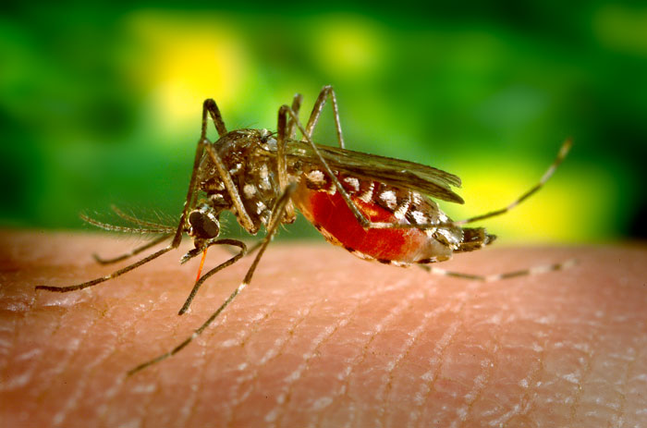
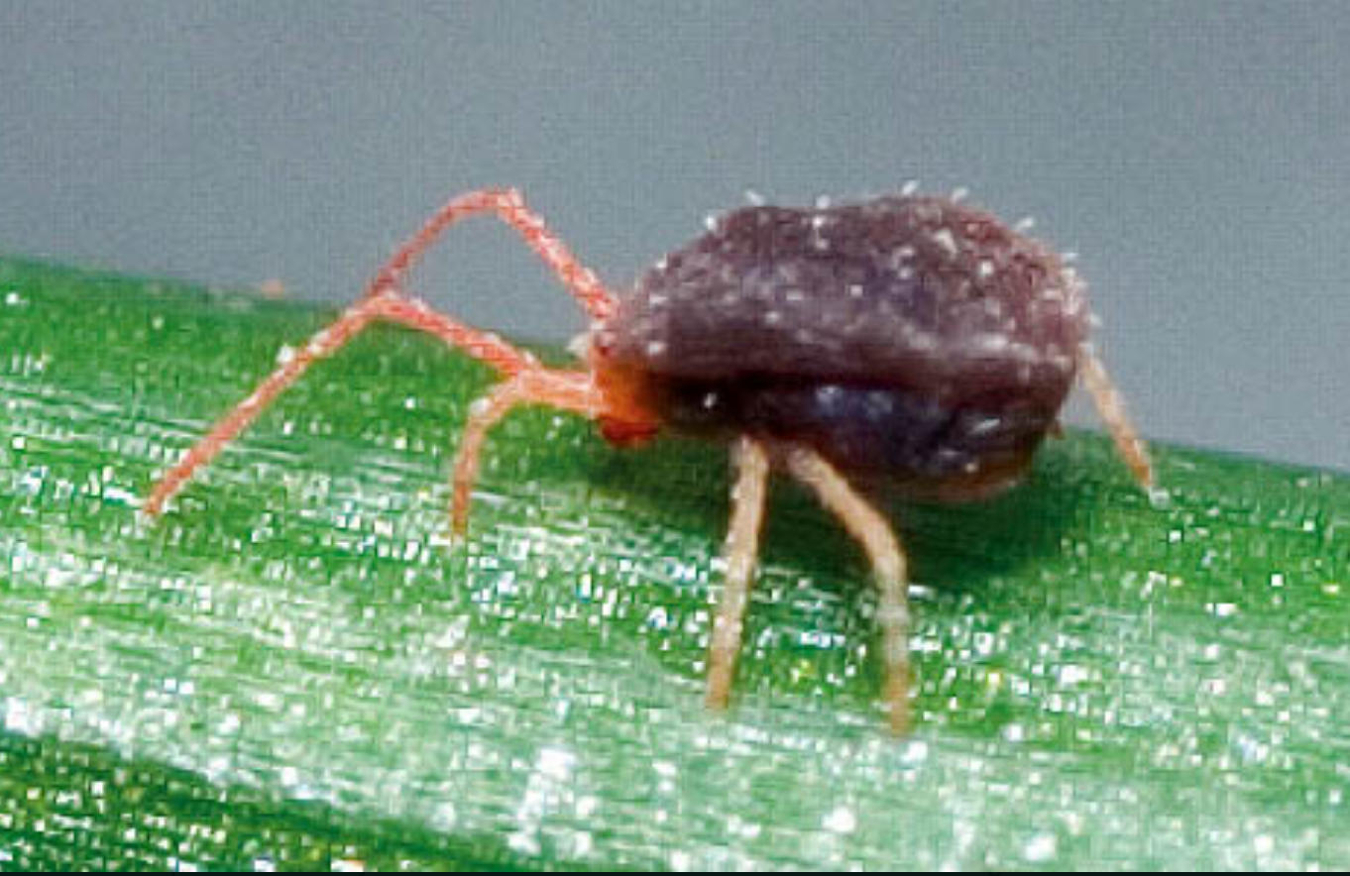
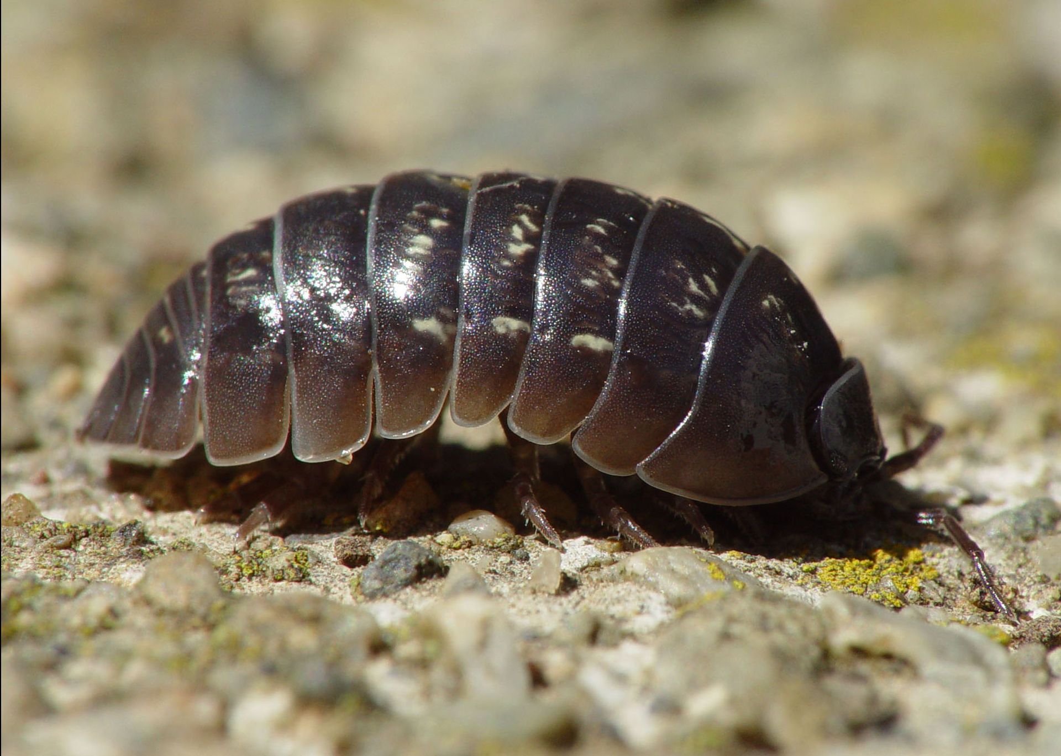
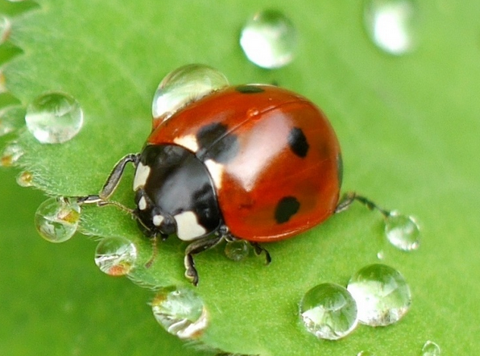
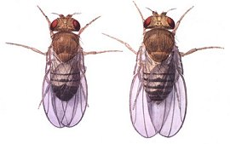
# Male offspring
# Female offspring
Reproductive phenotype
A
B
Student Notes

40%
antibiotics
endosymbiont
reproductive
Zika
phenotype
feminization
rescue
parthenogenesis
mitochondria
host

modifies
cytoplasmic incompatibility
mosquito
genotype
male-killing

Use the word bank to complete the statements below.

- Wolbachia is an obligate, intracellular ________________________. It lives within the cells of its eukaryotic ____________.
- Wolbachia infects approximately ____________ of all arthropods.
- Wolbachia resides in ________________________ tissues, such as ovaries and testes.
- Similar to ________________________, Wolbachia is maternally-transmitted.
- Wolbachia infections can be treated with ________________________.
- ____________________ is the genetic code (DNA) responsible for a particular trait whereas _____________________ is the visible or expressed trait.
- Wolbachia induces four reproductive phenotypes:
  - ________________________: Sons of infected females are selectively killed.
  - ________________________: Females reproduce asexually.
  - ________________________: Genetic males develop as phenotypic females.
  - ________________________: Wolbachia-infected males are incompatible with uninfected females.
- In cytoplasmic incompatibility, Wolbachia _________________ the sperm. Only a female with the same Wolbachia infection can _________________ the incompatibility.
- Some strains of Wolbachia inhibit the transmission of _________________-borne diseases, such as _________________, dengue, and chikungunya virus.

Research the association of Wolbachia with nematodes to complete the following section.

heartworm
filarial
mutualists

Beyond arthropods, Wolbachia also infect _________________ nematodes. Here, they act as ______________________ and are required for successful host development and reproduction. Therefore, a veterinarian might treat _______________________ with antibiotics to target the resident Wolbachia infection. Understanding this host-microbe symbiosis is critical for treating human diseases such as elephantiasis and river blindness.

Word Search



DNA
host
symbiont
Wolbachia
offspring

feminization
male killing
parthenogenesis
cytoplasmic incompatibility
reproductive parasitism

arthropods
genotype
phenotype
mutualists
filarial nematodes

Glossary

Clutch size: the number of offspring produced at one time.

Cytoplasmic incompatibility (CI): a reproductive phenotype in which sperm and egg are unable to produce viable offspring. In Wolbachia-induced CI, infected males modify the sperm and are incompatible with uninfected females. Only females with a similar Wolbachia symbiont can rescue the modification to produce viable offspring.

Endosymbiont: an organism that lives within another organism.

Feminization: a reproductive phenotype in which genetic males develop into phenotypic females.

Genotype: the genetic code (DNA) responsible for a particular trait.

Host: an organism in which (or on which) another organism lives.

Infected: harboring a microbial organism, in this case Wolbachia.

Male killing: a reproductive phenotype in which sons of infected females are selectively killed.

Offspring: the immediate descendants of an organism.

Parthenogenesis: a reproductive phenotype in which virgin mothers produce all female offspring from unfertilized eggs.

Phenotype: the visible or expressed trait of an organism.

Reproductive parasitism: the ability of a microbial symbiont, in this case Wolbachia, to influence the sexual reproduction of its host.

Symbiont: an organism living in close association with another, often larger, organism.

Uninfected: not harboring a microbial organism, in this case Wolbachia.

