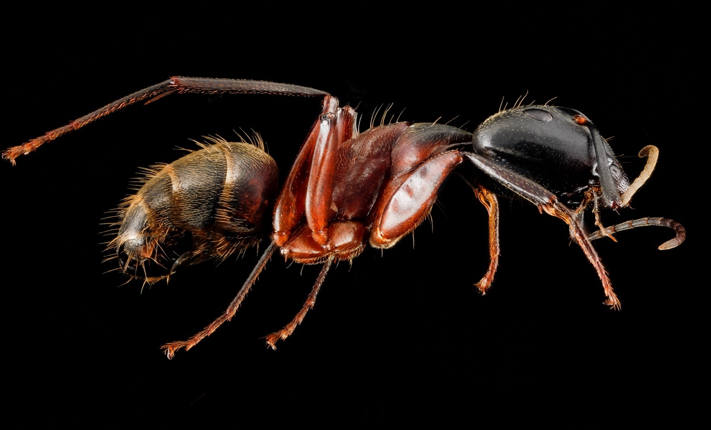

*Camponotus chromaiodes*

Claim • Evidence • Reasoning

*Using the data below, apply the CER Method to the following question:*

**Does *Wolbachia* infect red carpenter ants?**

**Claim:**

**Evidence:**

**Reasoning:**

*Methods:* Six red carpenter ants (*Camponotus chromaiodes*) were collected from multiple locations across campus. A duplex PCR was performed with primers targeting arthropod CO1 (708 bp) and *Wolbachia* 16S rRNA (438 bp). PCR products were loaded onto a TBE gel (1% agarose) stained with GelGreen. Gel electrophoresis results are shown below.

Lane 1: DNA Ladder

Lane 2: Ant #1

Lane 3: Ant #2

Lane 4: Ant #3

Lane 5: Ant #4

Lane 6: Ant #5

Lane 7: Ant #6

Lane 8: (-) Control

Lane 9: (+) Control

Lane 10: Water

**CLAIM:** Write a sentence stating whether *Wolbachia* can infect red carpenter ants.

**EVIDENCE:** Provide scientific data to support your claim. Use evidence from the above gel electrophoresis results.

**REASONING:** Describe why/how the evidence supports your claim.

*Camponotus chromaiodes* image available under Public Domain at [USGS Bee Inventory & Monitoring Lab](https://www.flickr.com/photos/usgsbiml/8387047079/in/photolist-dM8NTZ-dM8P9v)

