**Journal Club**

**Authors**

Cecilia Y. Hasan*

Reagan L. Sutton*

Jessica B. Sakash Replogle

* co-first authors

**Publication**

*Journal of Emerging Investigators*

15 October 2022

Volume 5

**Access**

<https://emerginginvestigators.org/articles/the-presence-of-em-wolbachia-em-in-brood-x-cicadas>

*Image of cicada emerging from nymph shell taken by Jessica B. Sakash Replogle.*

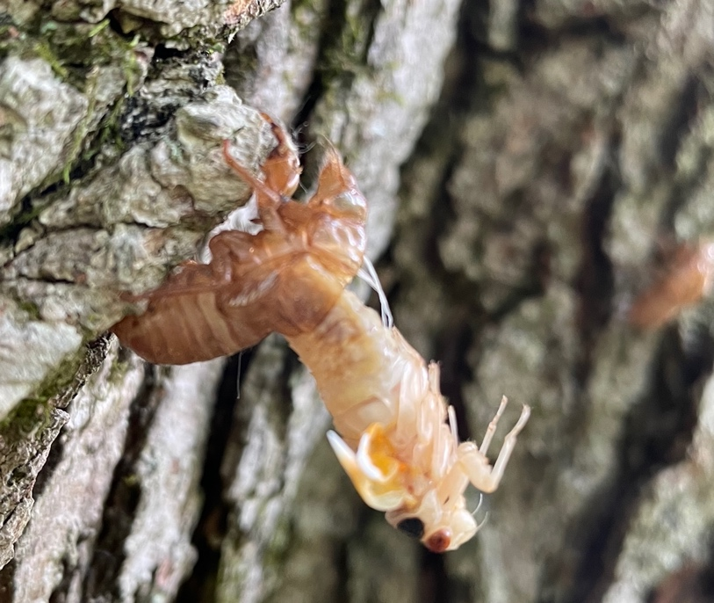

*Read the journal article and discuss the following questions with your class.*

**SUMMARY**

1. What is *Wolbachia*?
2. Which two insect species were explored in this study?
3. State the hypothesis of this research study.

**INTRODUCTION**

1. Define periodical organisms.
2. How often does Brood X emerge?
3. List the four *Wolbachia*-induced reproductive phenotypes.

**MATERIALS & METHODS**

1. When were the specimens collected?
2. Which part of each insect was used for DNA extraction?
3. Name the technique was used to amplify DNA. Which two genes were amplified?

**RESULTS**

1. How many cicadas were investigated in this study?
2. How many cicadas tested positive for *Wolbachia*?
3. How similar were the sequenced *M. septendecim* DNA sequences to the reference sequence in the national database?
4. How similar were the sequenced *M. cassini* DNA sequences to the reference sequence in the national database?

**Title**

The presence of *Wolbachia* in Brood X cicadas

Non-Profit Solutions **P.3**

Trends & New Software **P.4**

About the Authors

**Cecilia Y. Hasan**

**Cecila is a Summit Country Day School Class of 2022 graduate. She is majoring in Law, History and Society and Psychology / Prelaw at Vanderbilt University.**

**Reagan L. Sutton**

**Reagan is a Summit Country Day School Class of 2022 graduate. She is currently a Biological Sciences / PreMed major at the University of Southern California.**

**Jessica B. Sakash Replogle**

**Jessica is Head of the Schiff Family Science Research Institute at the Summit Country Day School. She is passionate about sharing her love of learning, asking questions and communicating science. Dr. Replogle has developed a research science program to engage high school students in authetic STEM research opportunities and get them hooked on searching for the answers to their “why?”. Dr. Replogle received her B.S. in biochemistry at the University of New Hampshire and her Ph.D. in biochemistry at the Merkert Chemistry Center, Boston College.**

**FIGURES**

**Figure 1**

1. List one morphological difference between *M. septemdecim* and *M. cassini*.
2. List one morphological difference between male and female cicadas.

**Figure 2**

1. Which species was/were collected West of Cincinnati?
2. Which species was/were collected near Sharonville?

**Figure 3**

1. In Figure 3A, what is the identity of Lane 1? Lane 2? Which of these is a positive *Wolbachia* control?
2. In Figure 3A, which lane is a negative control for both insect and *Wolbachia*?
3. In Figure 3B, which cicada has a positive *Wolbachia* amplification?

**Figure 4**

1. What are the two DNA sequences being aligned in Figure 4?
2. What is the % identity between these two sequences?

**Figure 5**

1. Based on this phylogenetic tree, the cicada amplicon is most closely related to which *Wolbachia* strain?
2. Whch phylogenetic clade (A, B, or D) is most closely related to clade C?

**General**

1. Do the figures adequately convey the major results from this paper? Why or why not?

**DISCUSSION**

1. Do the results of this paper support the hypothesis? Why or why not?
2. Describe a potential *false negative* result in this study.
3. Describe a potential *false positive* result in this study.
4. State one sampling limitation discussed in this study. How might scientists apply this information in future explorations of *Wolbachia*-cicada associations?
5. If you collected a cicada from your backyard, would you expect it to be infected with *Wolbachia*?

**Graphical Abstract**

***Create a graphical abstract to convey the methods and/or main findings of this paper.***

Graphical, or visual, abstracts capture the interest of readers and concisely summarize key findings of the research. They often accompany journal publications and news releases to highlight the main take-home messages.

Tips for Creating a Graphical Abstract

**PLAN**

1. Identify the main question(s) of the research study
2. Outline a workflow of the methods
3. Identity the key results/outcomes

**IMPLEMENT**

1. Create a template with 1-3 panels
2. Illustrate the above points using hand drawings, icons, or images
3. Avoid using images with a copyright; make sure they are freely available under public domain or a creative commons (CC) license and follow attribution guidelines
4. Be creative! Use text when needed; the majority of the abstract should be visual

**Other Resources for Free Images**

Wikimedia Commons: <https://commons.wikimedia.org>

Vecteezy: <https://www.vecteezy.com>

PhyloPic: <https://beta.phylopic.org>

Openverse: <https://wordpress.org/openverse>

Flaticon: <https://www.flaticon.com>

Bioicons: <https://bioicons.com>

1. Enter a keyword @ <https://www.google.com>
2. From the main results page, select **Images**
3. From the image results page, select **Tools**
4. Select **Usage Rights** >> **Creative Commons License**

**Google Search for CC Images**

